LangSmith Crash Course
Suppose a startup has a system that takes a Job Description (JD) and a resume, matches relevant keywords, and generates a customized cover letter.
Initially, the process takes around 2 minutes. However, after running the system for a few months, the same process starts taking 7–10 minutes.
This indicates that something in the system has become a performance bottleneck or is no longer scaling efficiently.
The problem is that an LLM workflow can contain many steps—multiple LLM calls, chains, retrieval, tools, and processing. When the workflow becomes slower, it is difficult to identify which particular step is taking the extra time.
This is where LangSmith comes in. It provides tracing and observability, allowing us to see each step of the workflow, how long it took, what input/output it had, and where the bottleneck occurred.
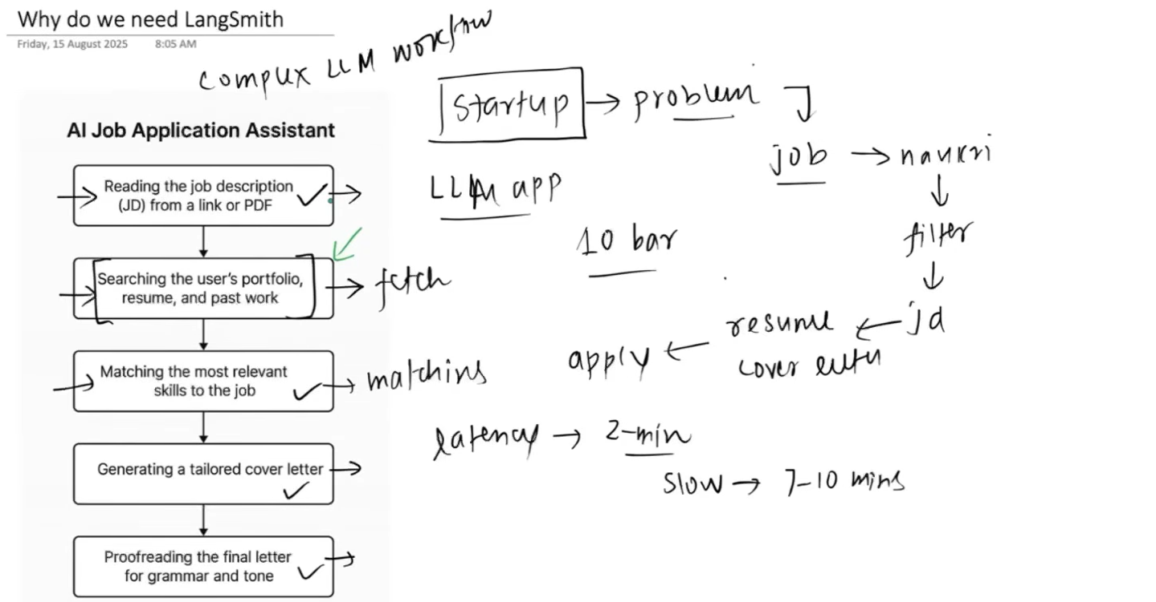

Since response of LLMs are non deterministic, its very hard to debug it and it sort of become a black box if we don’t observe it.
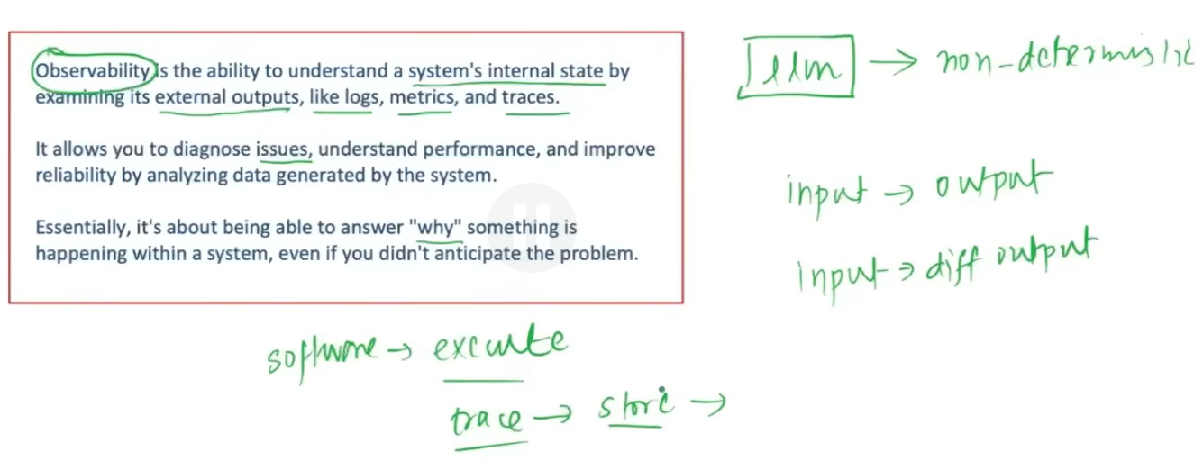
LangSmith is an observability and debugging platform for LLM applications. It helps us trace, monitor, evaluate, and debug what happens inside complex LangChain/LangGraph workflows.
It lets us see:
- Which LLM/model calls happened
- Input and output of each step
- How much time each step took
- Tokens and costs used
- Where errors or bottlenecks occurred
- The complete execution trace/flow of a request

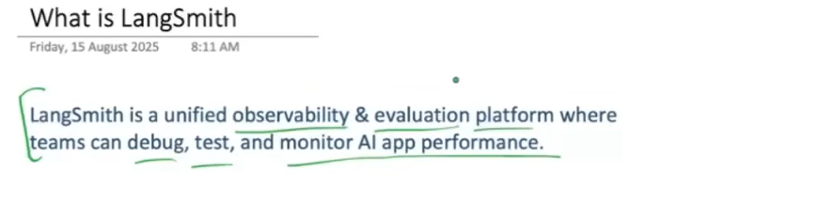
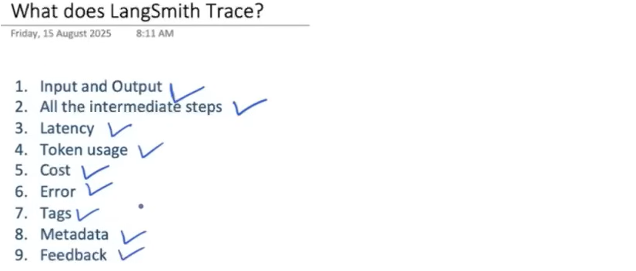

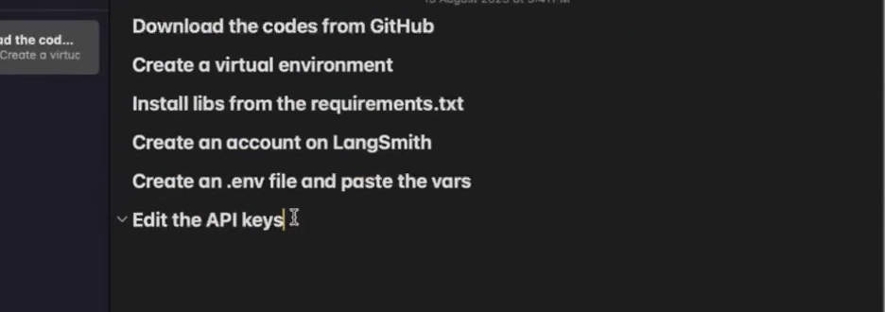

First, we create a LangSmith API key from the LangSmith website. This key allows our application to authenticate with LangSmith, where the traces and monitoring data of our LLM application are sent and viewed.
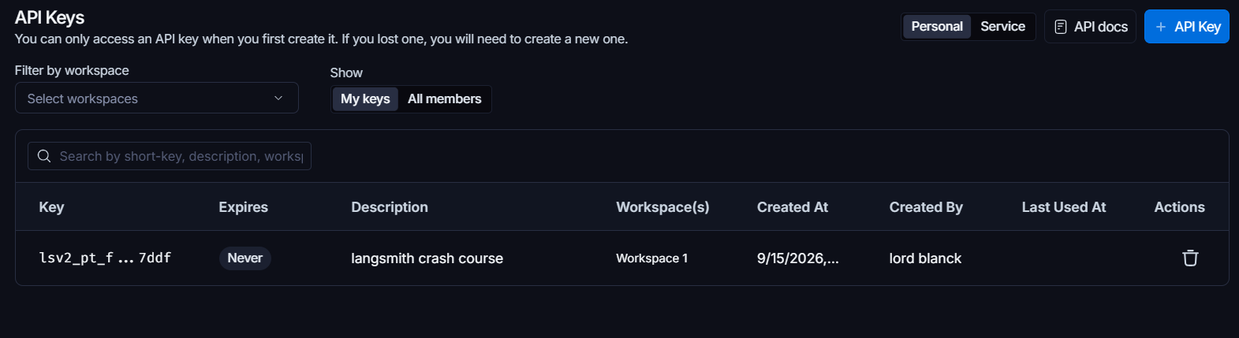
This is what we give in .env for this project.
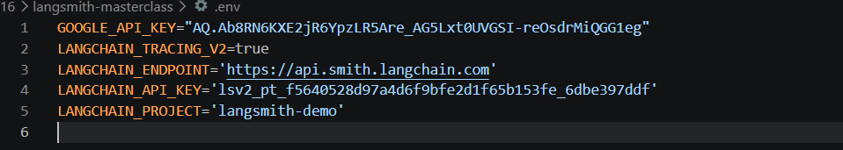
The entire LLM application inside the red rectangle is called a Project. Every time a user makes a request and the application executes, LangSmith creates a Trace for that complete execution. Inside that trace, each individual step that has its own input and output is represented as a Run.
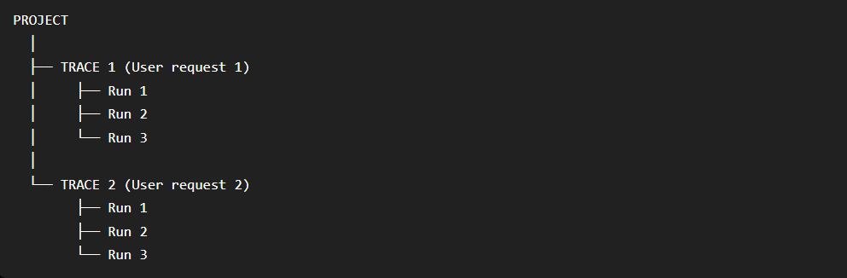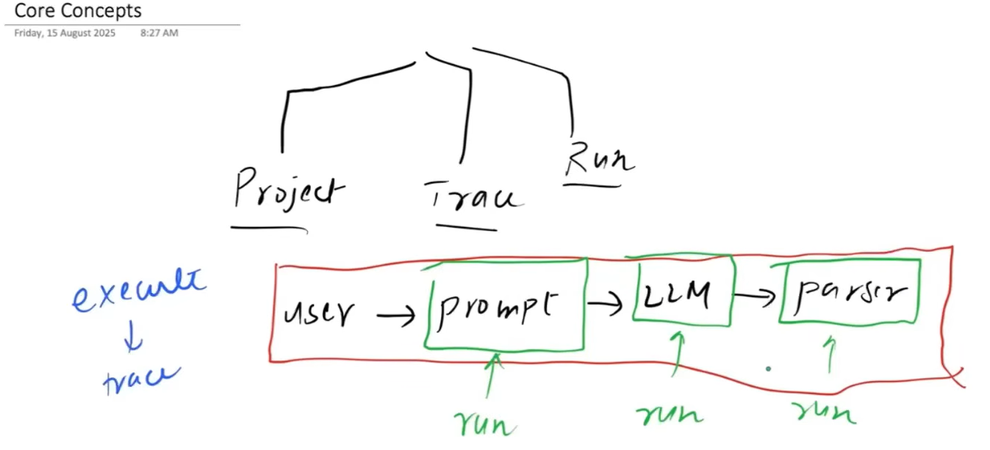

Code:- This is a basic LangChain project, with no LangGraph involved. Since the .env file contains the required LangSmith configuration values, LangChain automatically sends the execution information to LangSmith, where the runs can be tracked and viewed in the LangSmith dashboard.
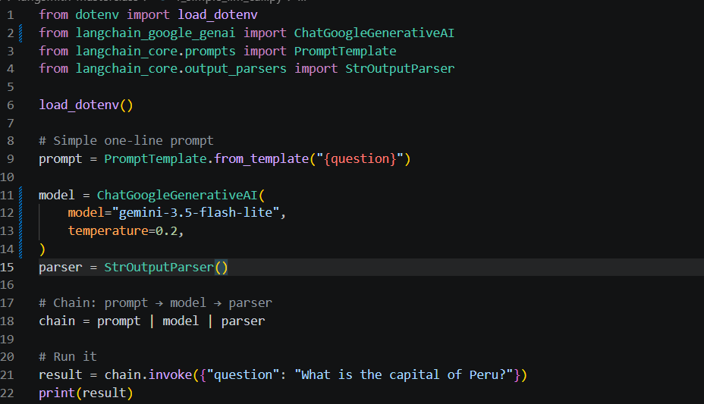
Observability – We can see all the projects we are running right now on top.
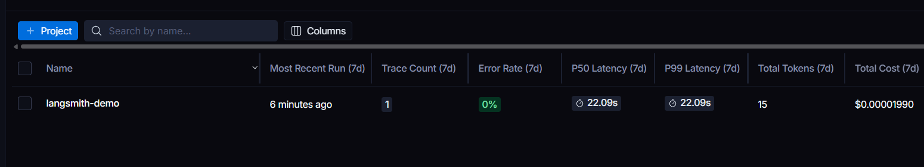
Here we can see detailed information about each run, such as the time taken, cost, most recent input and output, and other execution details. We can also see which Runnable/component was used during that particular step.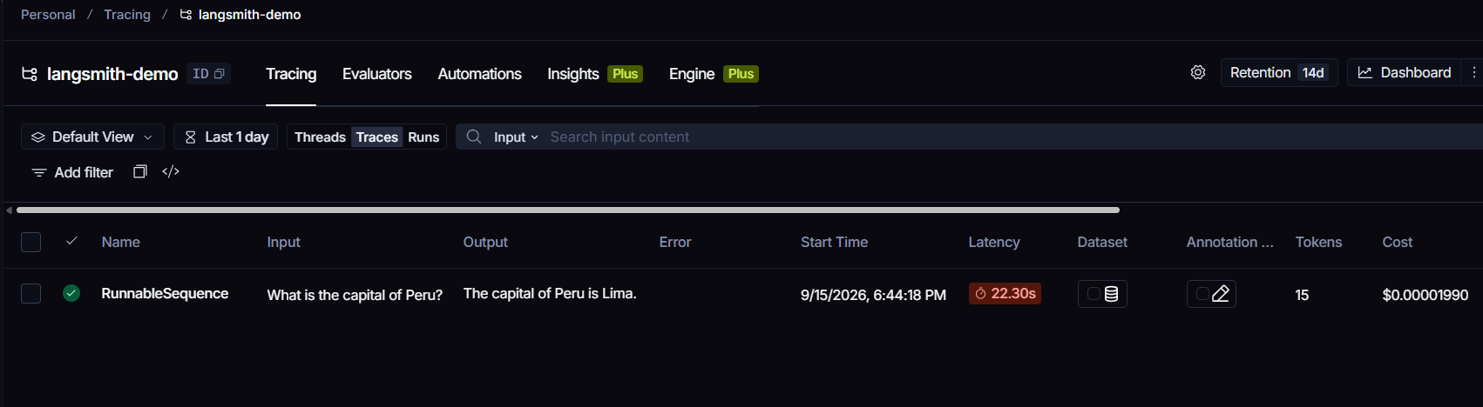

We can click on the Project name in LangSmith to view more detailed information about the application's execution. Inside the chain, each of the three sections/components is represented as a separate Run, allowing us to inspect their individual inputs, outputs, and execution details.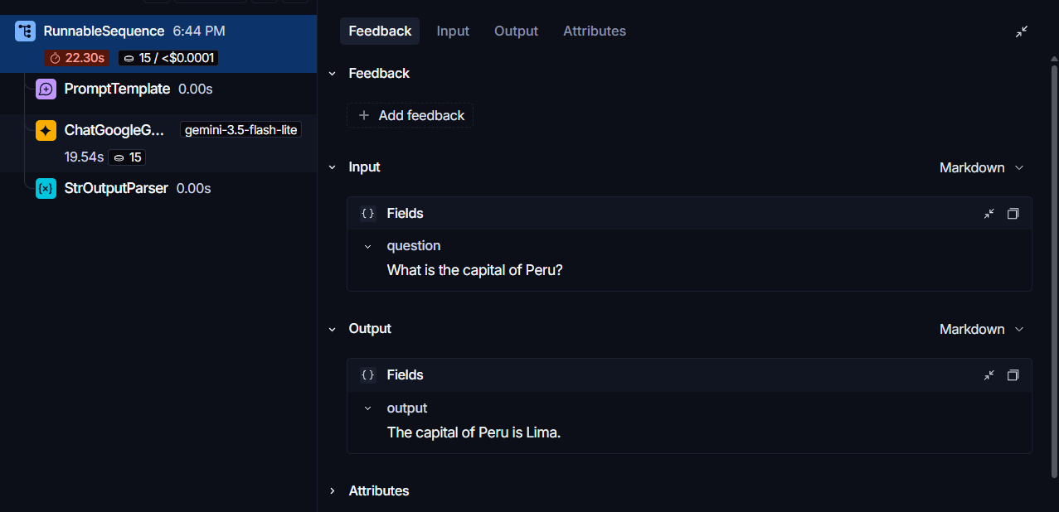

The hierarchy in LangSmith is:
Project -> Trace -> Run
When we run the application again:
- Project → remains the same because the application is still part of the same project.
- Traces → increase because each new execution creates a new trace.
- Runs → each trace contains its own set of runs representing the steps executed during that particular trace.
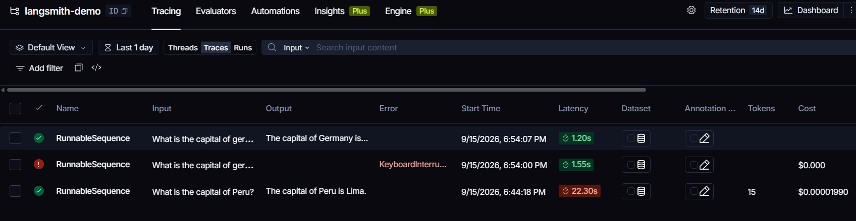

Code :- When we run the application again, the new traces will be added to the same project if the project name remains unchanged. We can create a separate project by either changing LANGCHAIN_PROJECT in the .env file or specifying a different project name in the code/configuration.
We can pass a config object during invoke() to attach additional information to that particular run, such as tags and metadata.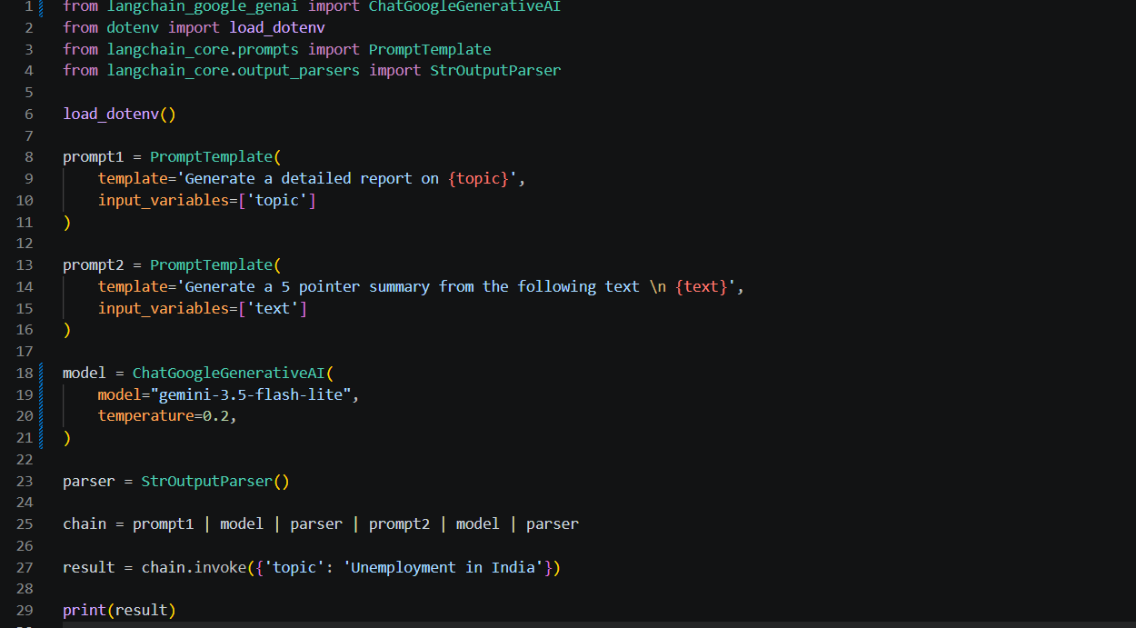
This is how it looks
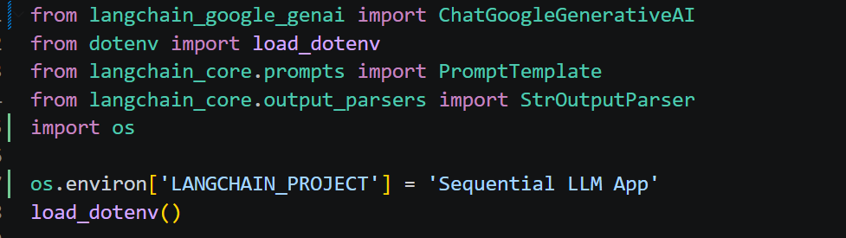
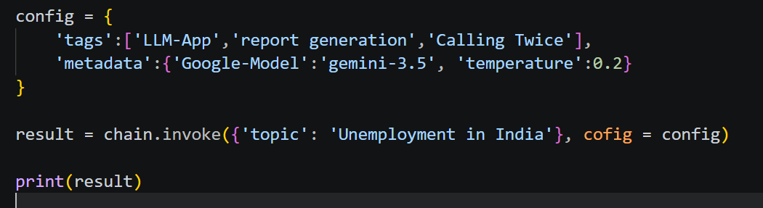
Obserbility on langsmith :- As we can see the top Project is with the name we gave.
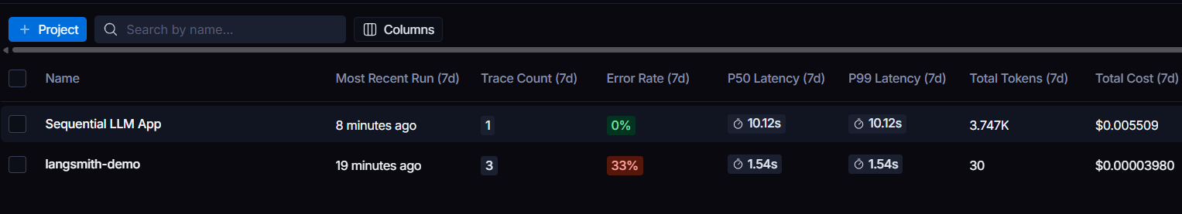
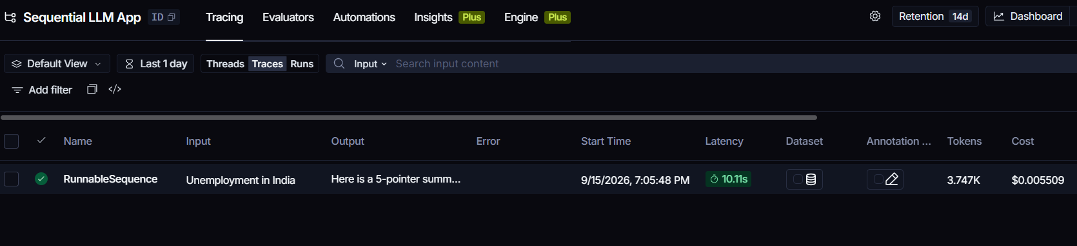

We can see the complete execution flow as expected in LangSmith. The tags and metadata we added through the config are also available in the run details, where we can view them whenever needed.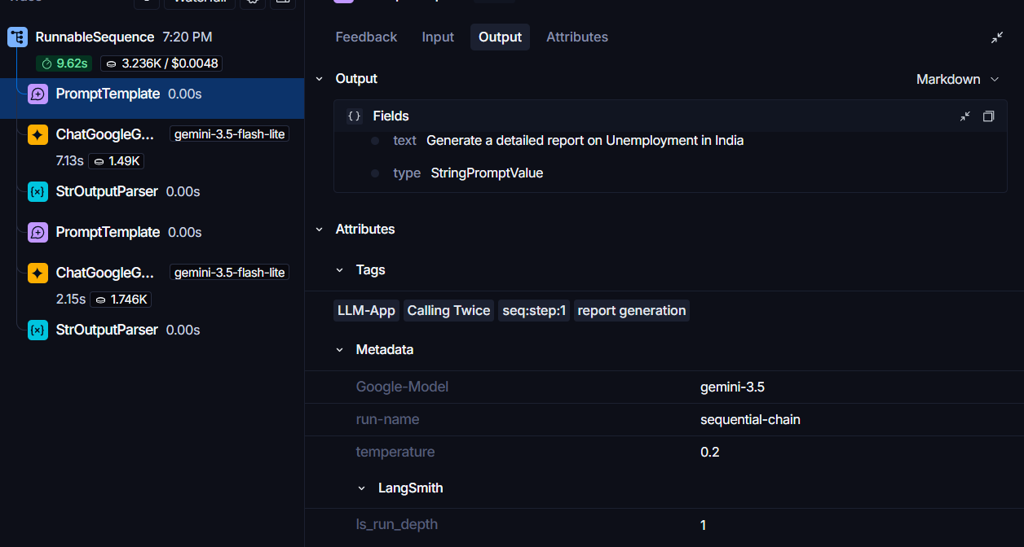
We can also change the name of an individual trace, without changing the project name. Since a new trace is created every time the application runs, we can give that particular trace a custom name using run_name in the config.
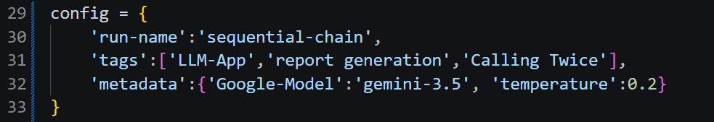
RAG generally involves two main things: first, retrieving the relevant subset of documents (context) based on the user's query, and second, giving the query + retrieved context to the LLM, which generates an answer based on that context.
Langsmith helps with the errors in the RAG system.
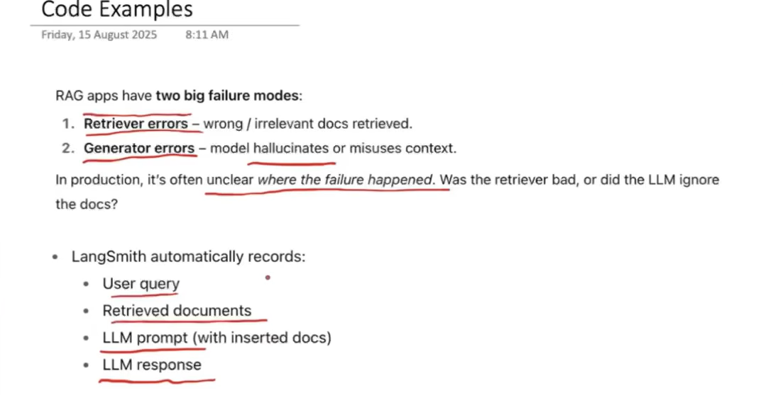
Code:- This is a basic RAG application, the only thing is that we changed the name of the project here.
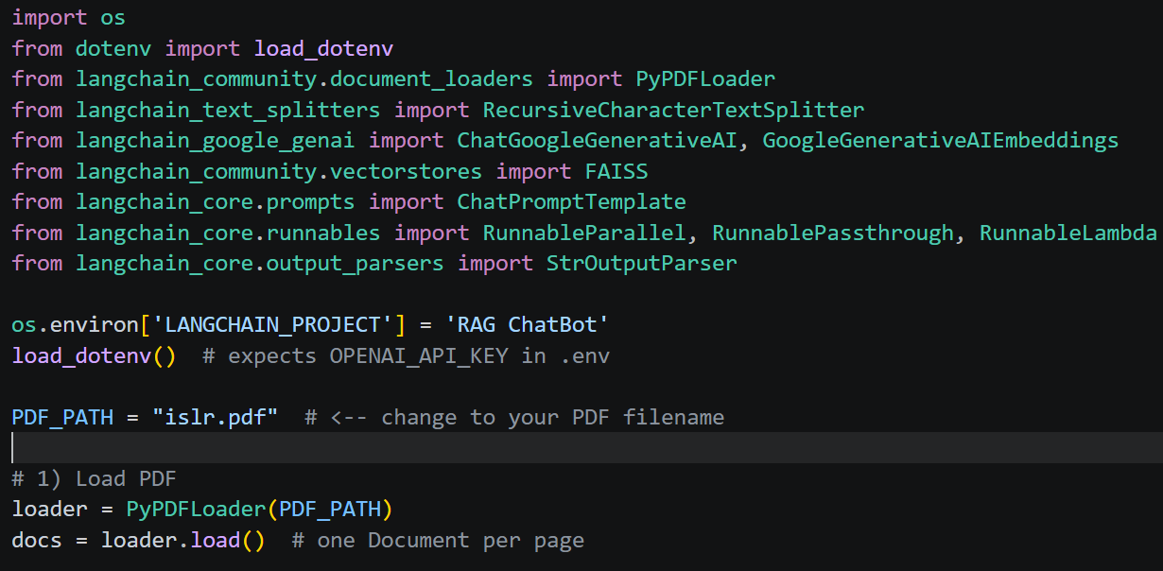
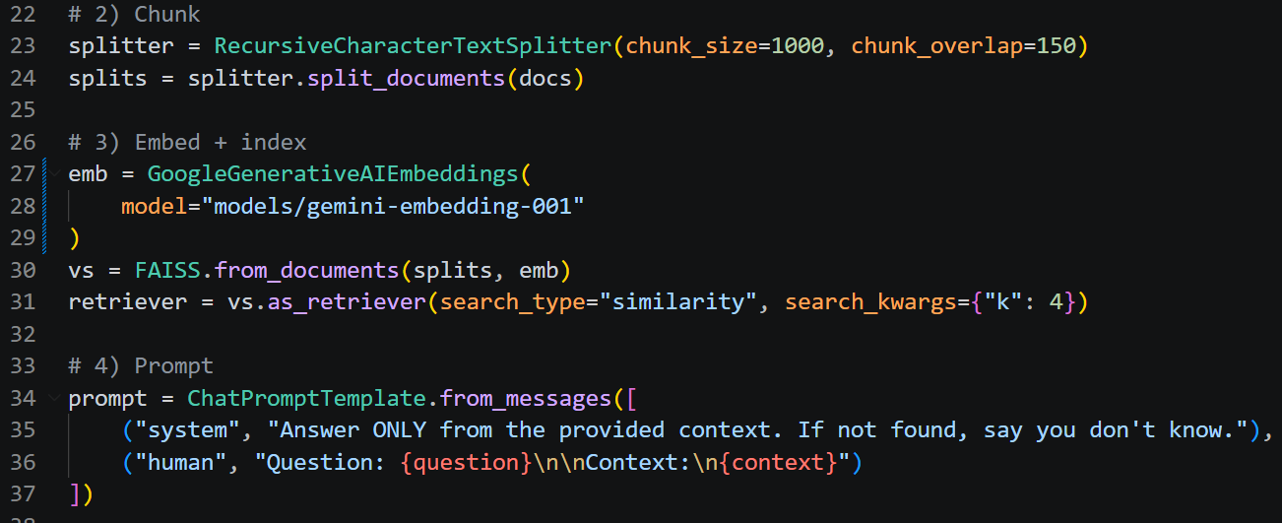
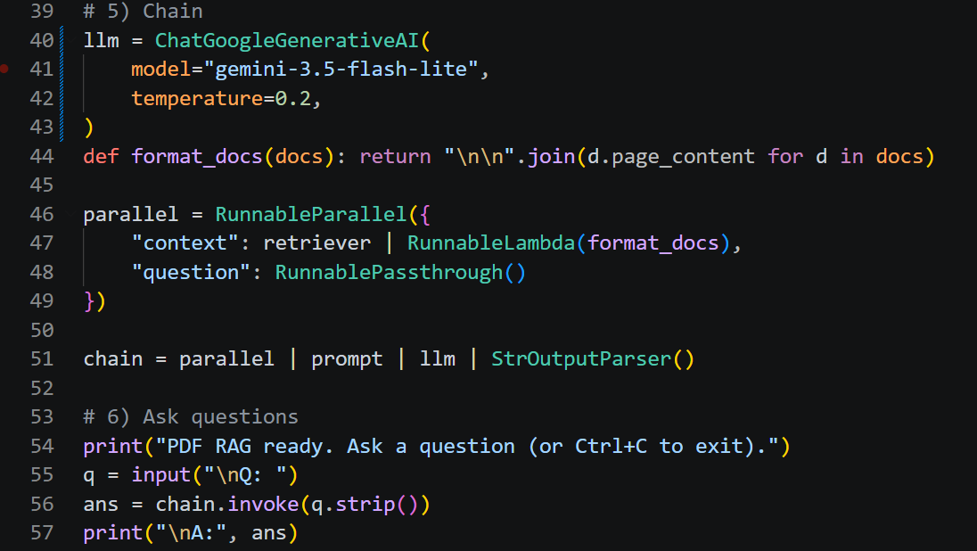
ResultAs we can see, LangSmith has information about the RAG chain, but it is not automatically tracing steps such as loading the PDF, chunking, embedding, and building the vector store.
This is because LangSmith automatically traces LangChain Runnables when they are executed through the Runnable interface, such as with .invoke(). The PDF loading, chunking, and indexing functions in our code are normal Python/library operations, so they are not automatically traced as individual runs.
The second issue is that every time we start the program, the entire indexing process runs again. It loads the PDF, splits it into chunks, creates embeddings for those chunks, and stores them in the vector store again.
This takes unnecessary time because the PDF and its configuration may not have changed.
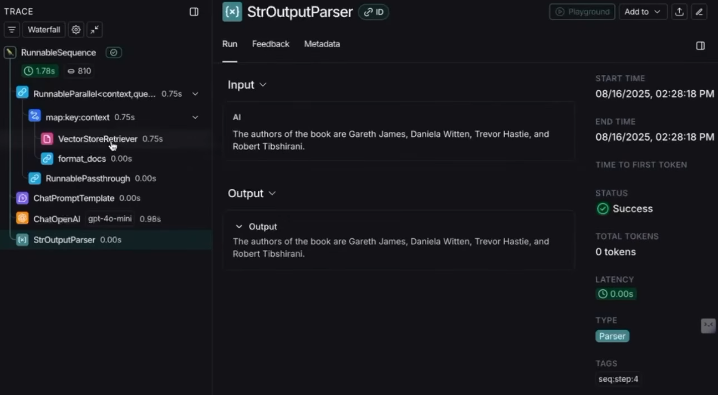
Question 1- To trace the loading, splitting, embedding, and vector-store creation, we use the @traceable decorator on the normal Python functions performing those steps.
Code:- Here we import traceable, which allows us to tell LangSmith to trace specific Python functions. It is a decorator, so we place @traceable above the function we want LangSmith to monitor.
A decorator is used to add extra behavior to a normal Python function without changing the function's main logic.
In LangChain, decorators are commonly used to make your normal functions traceable, observable, or integrate them into LangChain workflows even if they aren’t runnable.

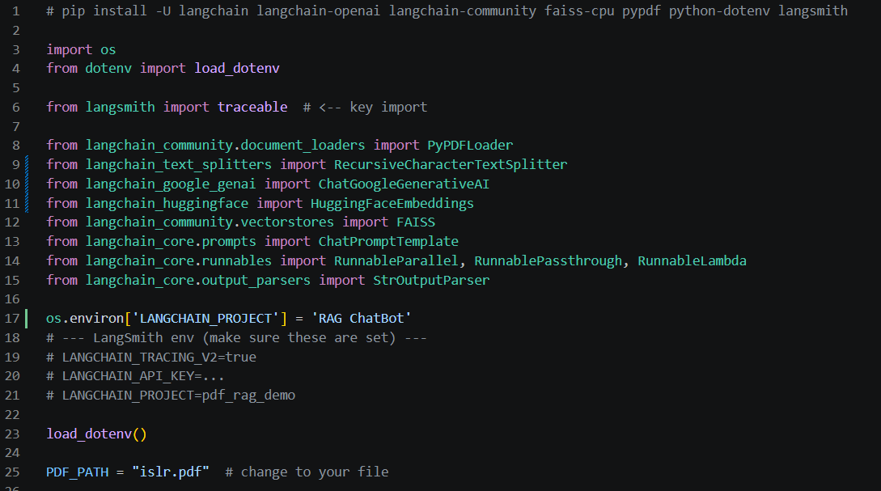
We convert the normal processing steps into Python functions and add the @traceable decorator so that LangSmith can track each function's execution. We can also provide a custom name for each trace, which will be displayed in the LangSmith tracer.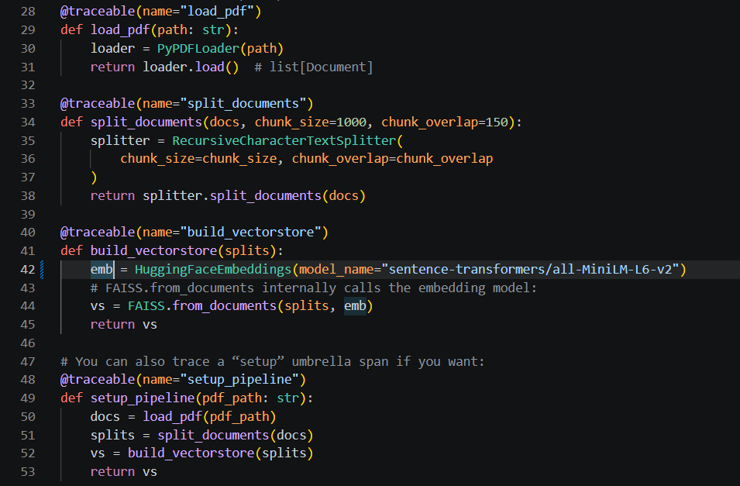
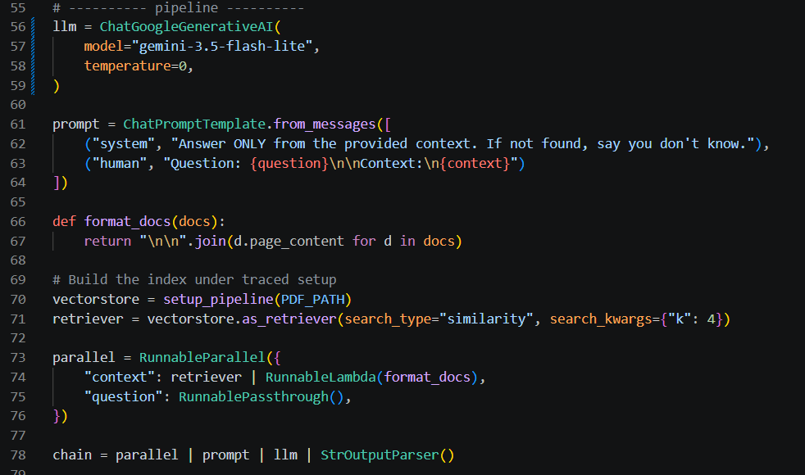
Compared to Version 1 of the RAG application, we make a small change by changing the trace name from the default RunnableSequence to a custom name, pdf_rag_query..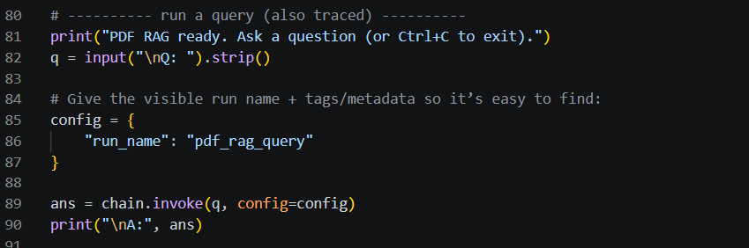
Result on Langsmith –
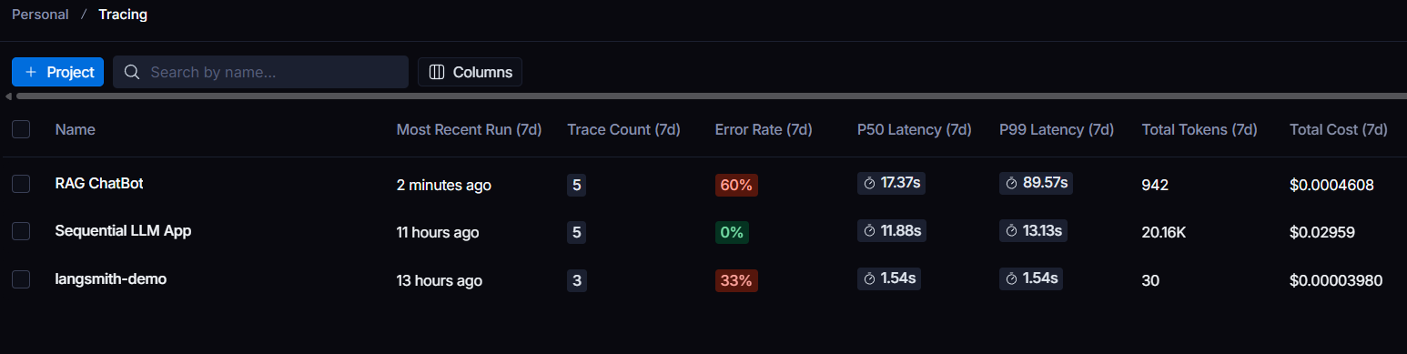
First three failed in past. But our most recent one is there.
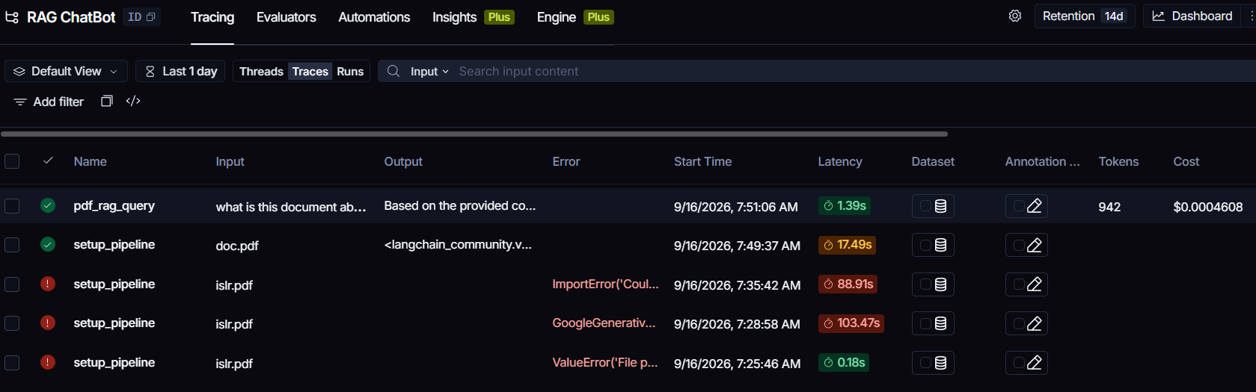
We even asked it a question about this document and it answered. And also as we can see,
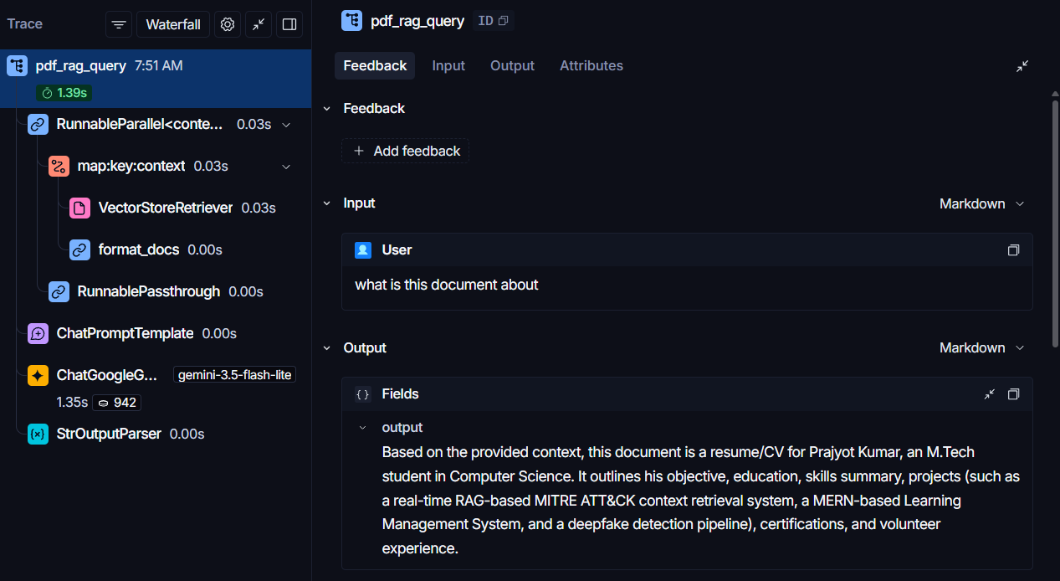

Here we can see the normal RAG trace as before, but the three additional functions where we added the @traceable decorator are not shown as normal Runnable steps. Instead, their execution appears under a separate trace called setup_pipeline.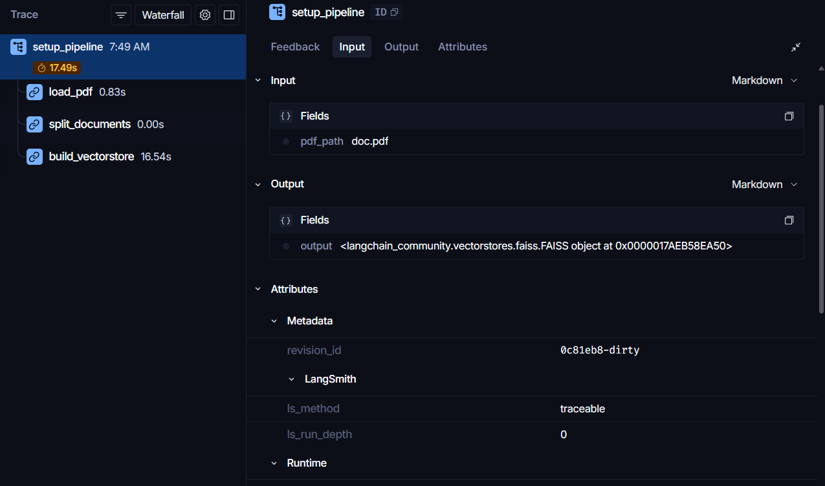
Currently, LangSmith is showing the setup process and RAG query as separate traces, even though both are part of the same application. To get a proper hierarchy, we create one parent trace for the entire workflow, with setup_pipeline and pdf_rag_query appearing as child runs under it.
Also if we want, we can attach tags and metadata to these decorators.
Code:-
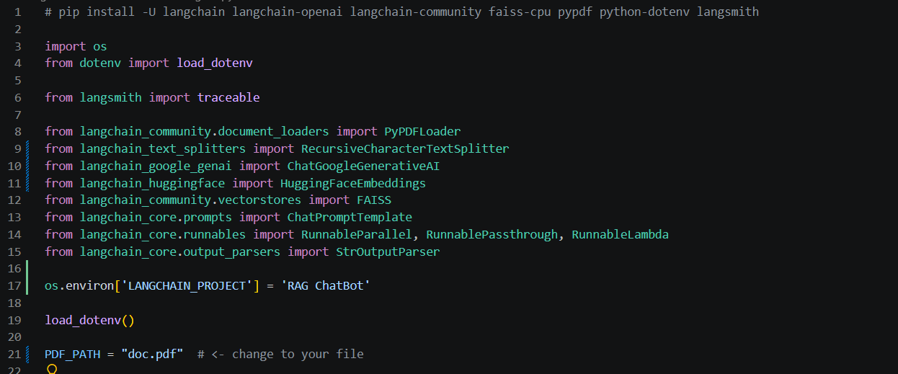
Not a change in these parts apart from sending meta and
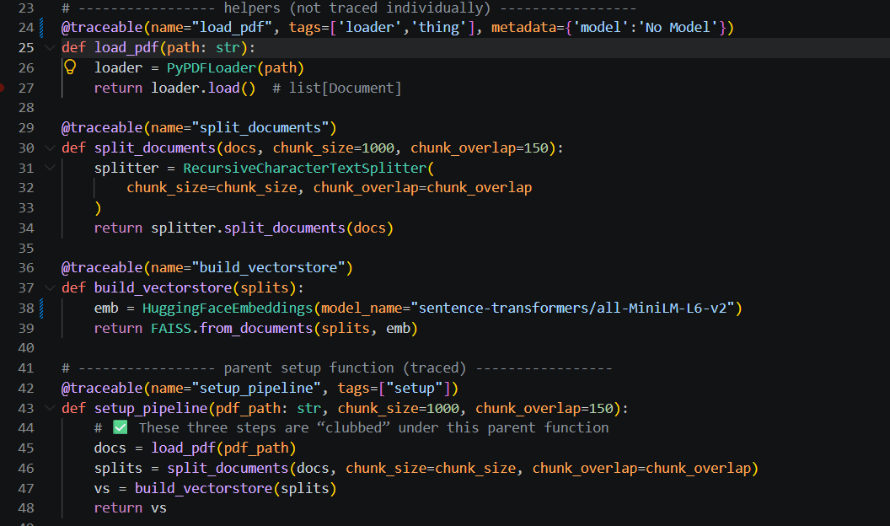
Here as we can we put the entire thing under one tracable.
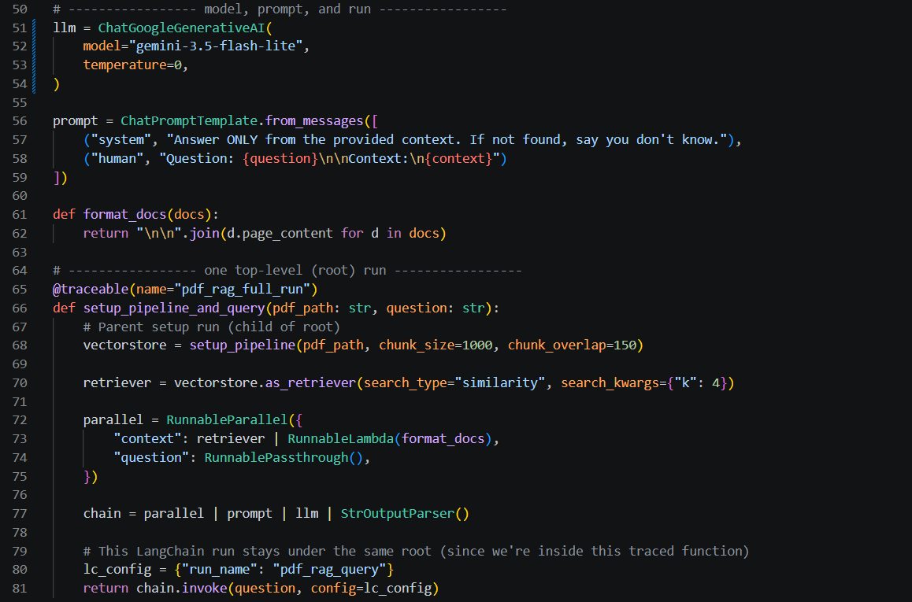
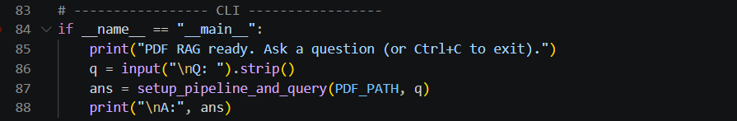
Result:- We named the two non-Runnable functions setup_pipeline and pdf_rag_query using the @traceable decorator. When these functions execute, LangSmith uses the names we provided as the names of their traces/runs in the LangSmith dashboard.
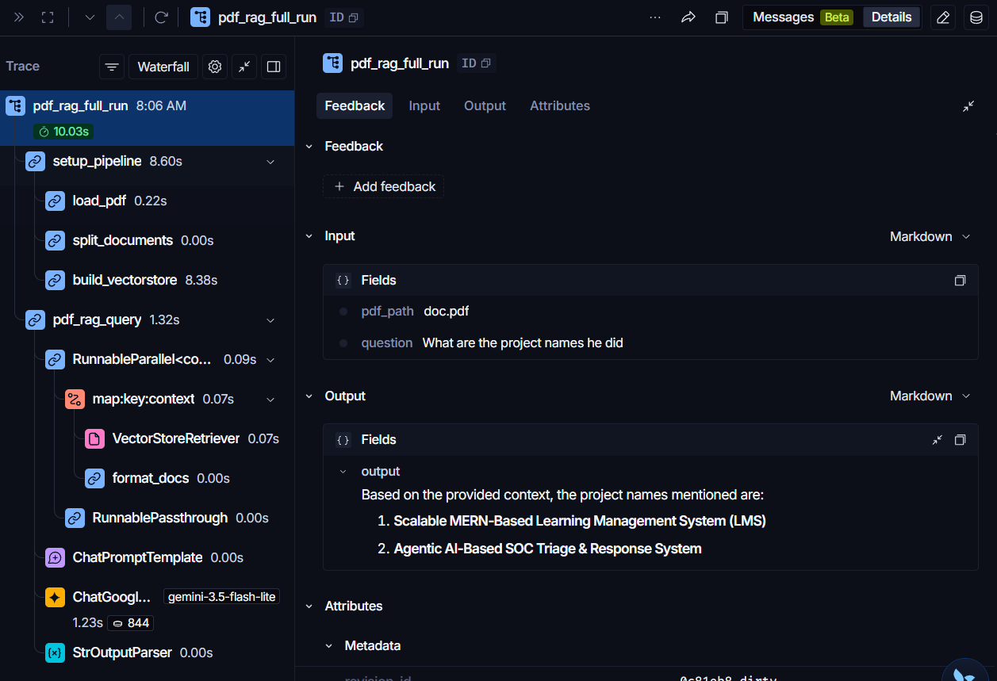
Tags and metadata make traces easier to search and filter in LangSmith. We can click or search for a particular tag or metadata value to find all the traces that contain it.
Question 2 – The latency increases because every time the application runs, it repeats expensive steps such as loading the PDF, splitting it into chunks, generating embeddings, and storing them in the vector database.
Answer – The first time we run the program, we build the FAISS index by loading the PDF, splitting it, creating embeddings, and storing the vectors. On subsequent runs, we check whether the index already exists; if it does, we simply load and reuse it instead of rebuilding everything.
Code:-
This creates a directory (folder) at the path stored in INDEX_ROOT.
- mkdir() → creates the directory.
- exist_ok=True → doesn't give an error if the directory already exists.
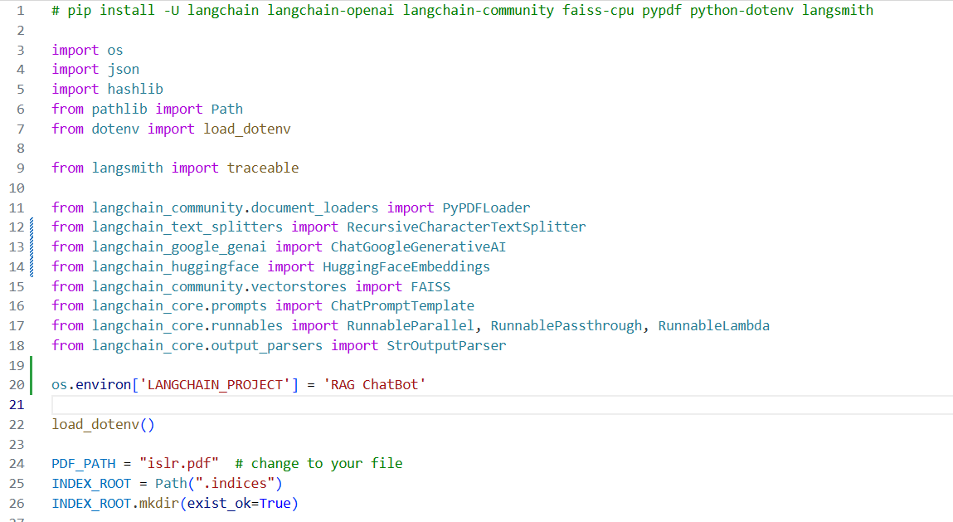
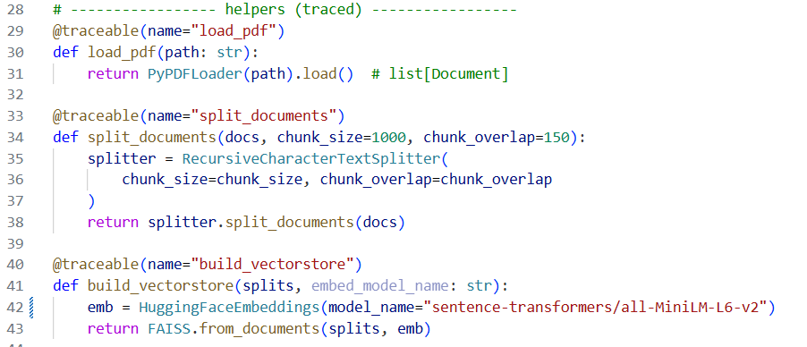

_file_fingerprint(path)
This function creates a unique fingerprint for a file so we can detect whether the file has changed. It calculates the file's SHA-256 hash, size, and last-modified time.
Explanation:
- path: str → takes the file path as a string.
- Path(path) → converts the path into a Path object.
- hashlib.sha256() → creates a SHA-256 hash calculator.
- p.open("rb") → opens the file in binary read mode.
- f.read(1024 * 1024) → reads the file in 1 MB chunks instead of loading the entire file into memory.
- iter(..., b"") → keeps reading until an empty byte string (b"") indicates the end of the file.
- h.update(chunk) → adds each chunk to the SHA-256 calculation.
- h.hexdigest() → converts the final hash into a hexadecimal string.
- p.stat().st_size → gets the file size in bytes.
- p.stat().st_mtime → gets the file's last modification time.
- int(...) → converts that timestamp to an integer
_index_key(...)
This function creates a unique key for a particular vector index configuration. It combines the PDF's fingerprint, chunking settings, and embedding model, then generates a SHA-256 hash.
Explanation:
- pdf_path → path of the PDF.
- chunk_size → size used for splitting the PDF.
- chunk_overlap → overlap between chunks.
- embed_model_name → embedding model being used.
- _file_fingerprint(pdf_path) → identifies the exact version of the PDF.
- meta → stores all these details together.
- "format": "v1" → identifies the version of the index format.
- json.dumps(meta, sort_keys=True) → converts meta into consistent JSON.
- .encode("utf-8") → converts the JSON into bytes for hashing.
- hashlib.sha256(...) → generates a unique hash.
- .hexdigest() → returns the hash as a hexadecimal string.
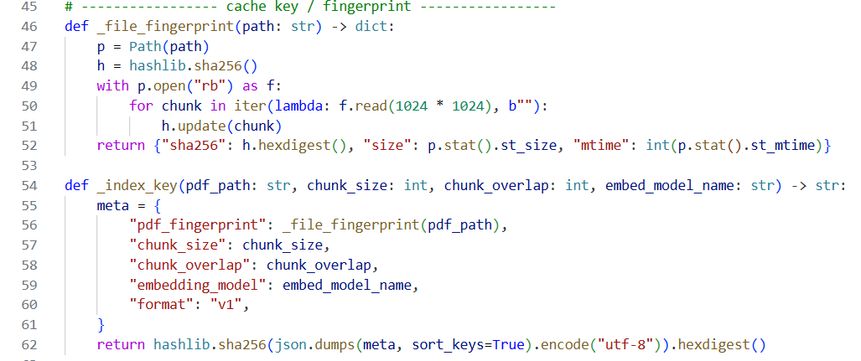
load_index_run(...)
This function loads an existing FAISS vector index from disk and is also traced in LangSmith.
Explanation:
- @traceable(...) → tells LangSmith to trace this function.
- name="load_index" → gives the trace a custom name: load_index.
- tags=["index"] → adds the index tag in LangSmith for filtering/identifying this run.
- index_dir: Path → path to the directory containing the saved FAISS index.
- embed_model_name: str → embedding model name passed to the function.
- HuggingFaceEmbeddings(...) → creates the embedding model used with the stored FAISS index.
- FAISS.load_local(...) → loads the previously saved FAISS index from index_dir.
- str(index_dir) → converts the Path object into a string.
- allow_dangerous_deserialization=True → allows FAISS to deserialize the saved index; this should only be used with trusted index files.
build_index_run(...)
This function builds and saves a FAISS vector index from a PDF, while LangSmith traces the entire process and its child functions.
Explanation:
- @traceable(...) → tells LangSmith to trace this function.
- name="build_index" → gives the trace the custom name build_index.
- tags=["index"] → adds the index tag in LangSmith.
- load_pdf(pdf_path) → loads the PDF. This appears as a child trace.
- split_documents(...) → splits the PDF into chunks. Another child trace.
- build_vectorstore(...) → creates the FAISS vector store from the chunks. Another child trace.
- index_dir.mkdir(...) → creates the directory where the index will be stored. parents=True also creates missing parent directories.
- vs.save_local(...) → saves the FAISS index to that directory.
- meta.json → saves information about the PDF, chunk settings, and embedding model.
- return vs → returns the created FAISS vector store.
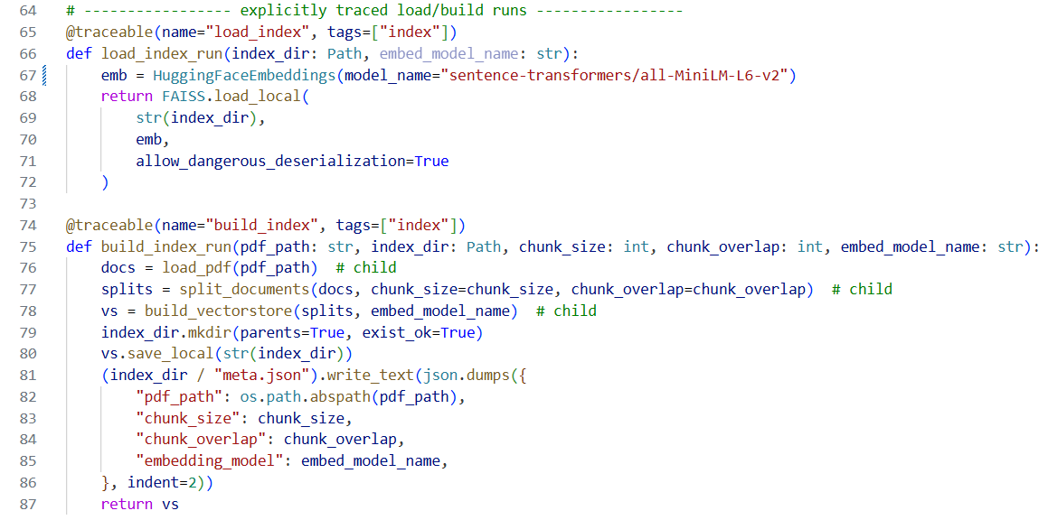
load_or_build_index(...)
This function checks whether a suitable FAISS index already exists. If it exists, it loads it; otherwise, it builds a new one.
Explanation:
- _index_key(...) → creates a unique key based on the PDF + chunk settings + embedding model.
- index_dir = INDEX_ROOT / key → creates the path where that specific index should be stored.
- index_dir.exists() → checks whether that index already exists.
- not force_rebuild → ensures we don't use the existing index when rebuilding is explicitly requested.
- cache_hit → becomes True when an existing index can be reused.
- load_index_run(...) → loads the existing FAISS index.
- build_index_run(...) → creates a new FAISS index and saves it.
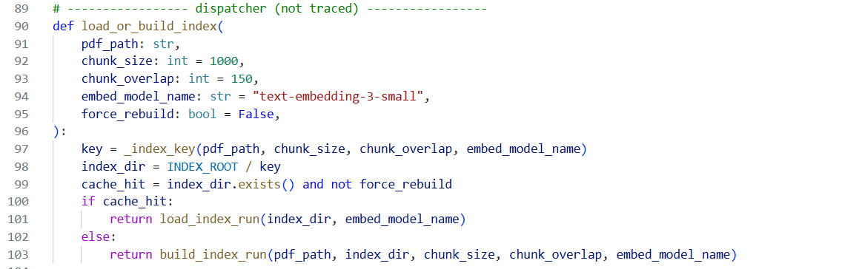
setup_pipeline(...)
This function is the main setup function for the RAG pipeline. It is traced by LangSmith and calls load_or_build_index() to either load an existing FAISS index or build a new one.
Explanation:
- @traceable(...) → allows LangSmith to trace this setup process.
- name="setup_pipeline" → gives the trace the custom name setup_pipeline.
- tags=["setup"] → adds the setup tag in LangSmith.
- pdf_path → path of the PDF.
- chunk_size → size of each chunk, default 1000.
- chunk_overlap → overlap between chunks, default 150.
- embed_model_name → embedding model to use.
- force_rebuild → decides whether to force a new index.
- return load_or_build_index(...) → passes all these settings to the function that handles loading or building the index.
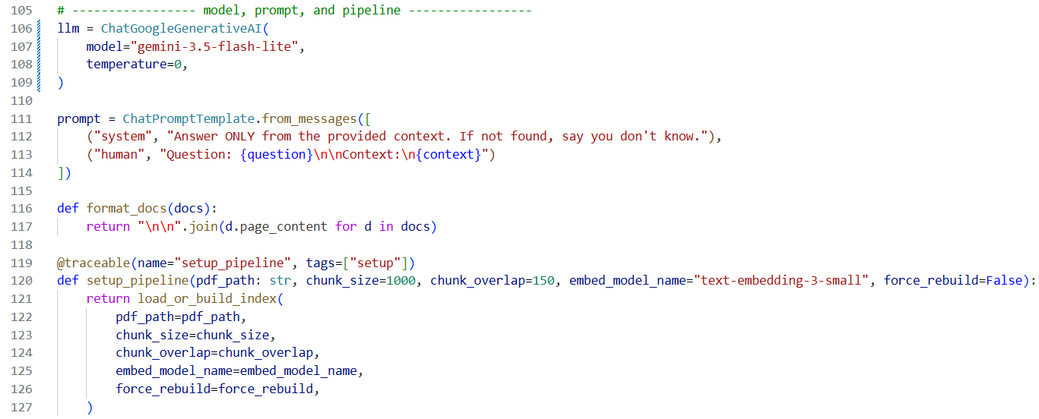
setup_pipeline_and_query(...)
This function runs the complete PDF RAG workflow in one function and lets LangSmith trace the entire execution.
Explanation:
- @traceable(name="pdf_rag_full_run") → tells LangSmith to trace the complete workflow with the custom name pdf_rag_full_run.
- pdf_path → PDF to use.
- question → user's question.
- setup_pipeline(...) → loads an existing vector index or builds a new one.
- retriever = vectorstore.as_retriever(...) → creates a retriever that finds the 4 most relevant chunks.
- RunnableParallel → prepares both:
  - context → retrieves relevant documents and formats them.
  - question → passes the original question through.
- chain = parallel | prompt | llm | StrOutputParser() → creates the RAG chain.
- chain.invoke(...) → sends the question through the complete chain.
- run_name="pdf_rag_query" → names the query trace in LangSmith.
- tags=["qa"] → marks this run as a question-answering run.
- metadata={"k": 4} → stores additional information that k=4 was used.
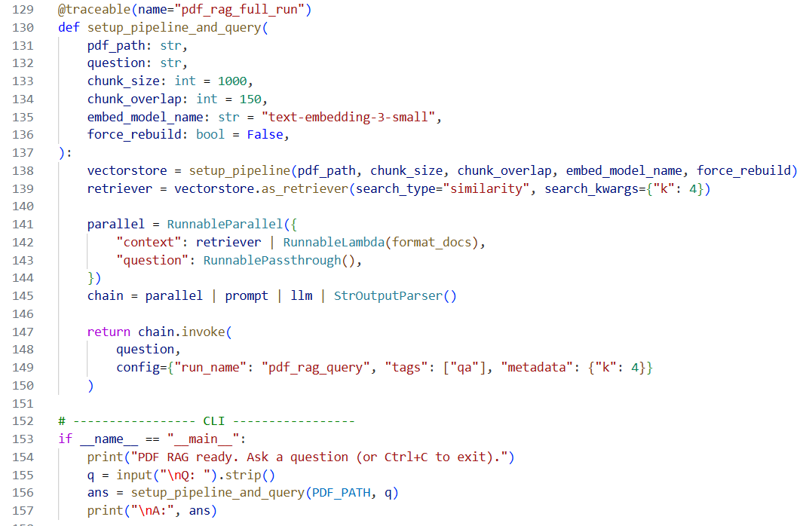
Result:- As we can see, the newest run took only ~9 seconds, while the second run from the top took ~234 seconds.
The reason is that the 234-second run was the first time the pipeline was executed. It had to:
Load PDF → Split PDF → Create Embeddings → Build FAISS Index → Save Index → Retrieve Answer
On subsequent runs, the FAISS index was already available, so the pipeline simply:
Load Existing FAISS Index → Retrieve Relevant Chunks → Generate Answer
Therefore, the expensive PDF processing and embedding creation happen only when the index needs to be built, which significantly reduces the response time on later runs.
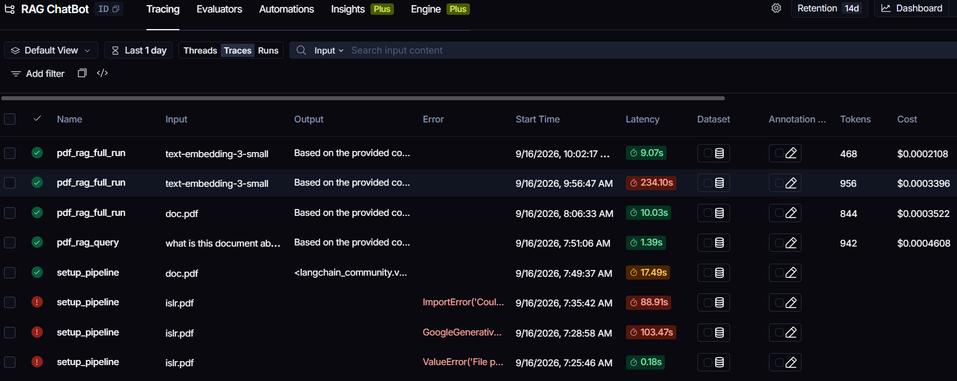
This is the first time we are running the pipeline. As we can see, it includes the build_index process.
During this run, the system has to:
Load PDF → Split Documents → Create Embeddings → Build FAISS Index → Save Index
Since the FAISS index does not exist yet, all of these steps need to be performed before the system can answer the query.
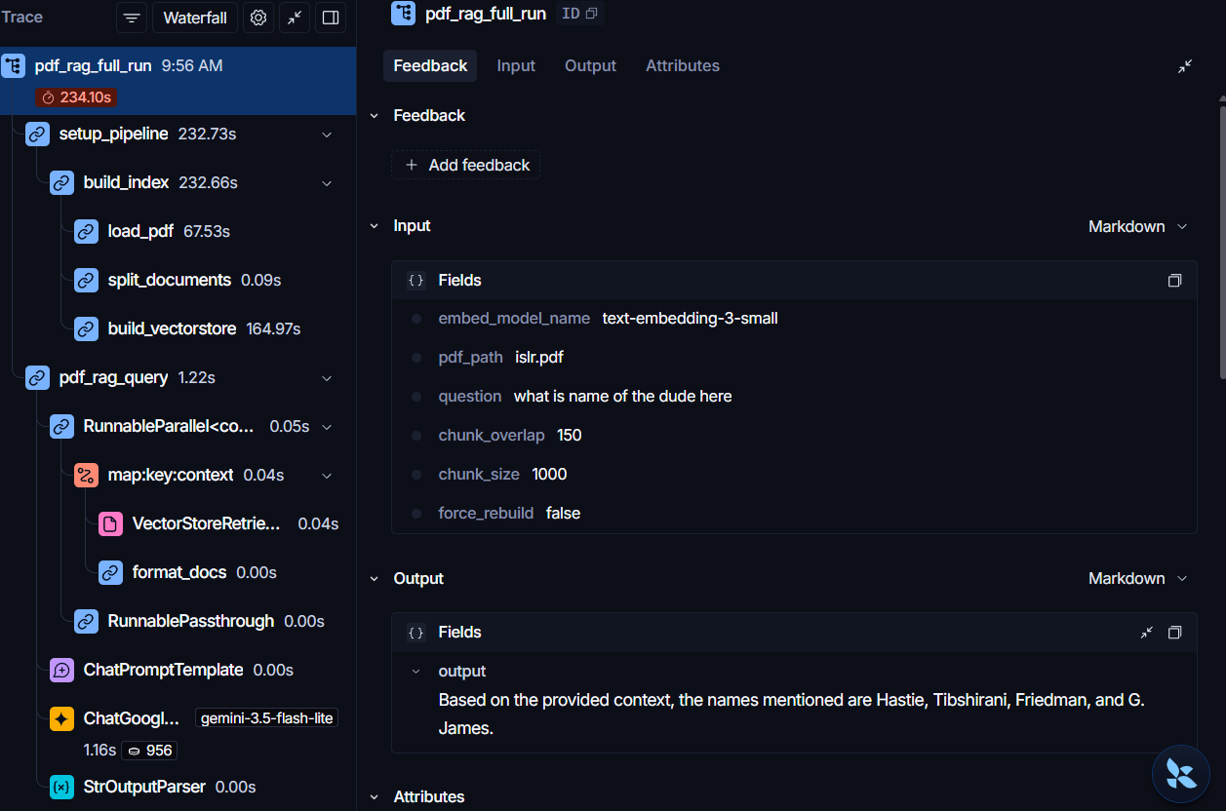
This is the second time we run it. As we can see, it uses the load_index process to load the previously created FAISS index and give us the answer.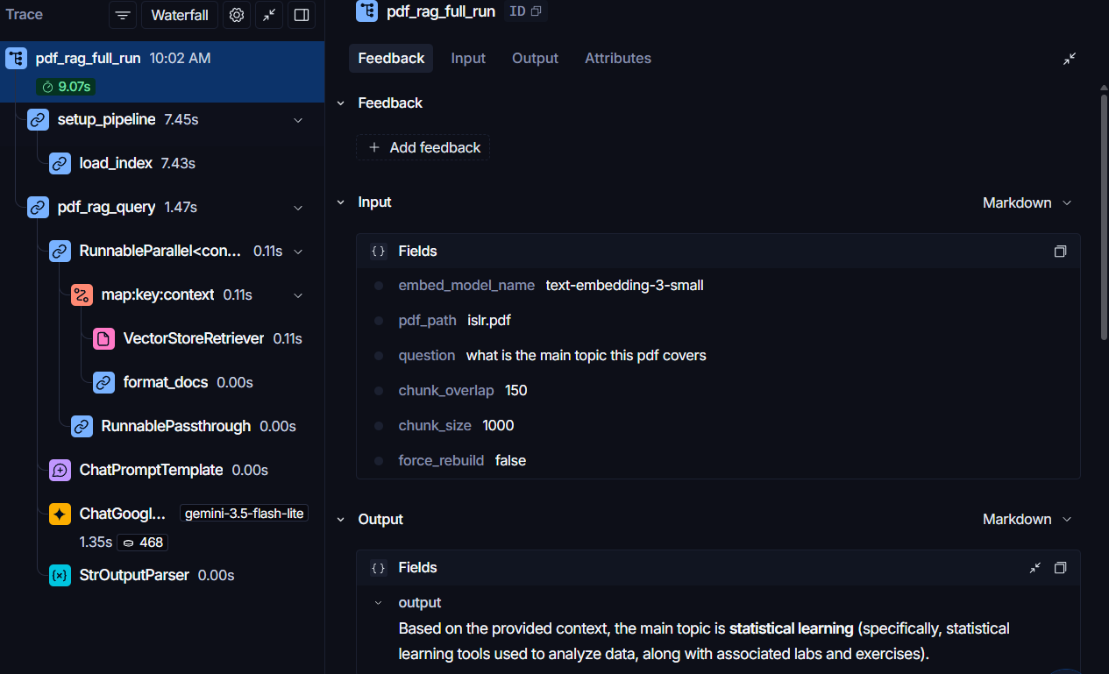
These are the two cases we handle: build_index when the index doesn't exist, and load_index when it already exists. Apart from the first build, subsequent runs will load the existing index.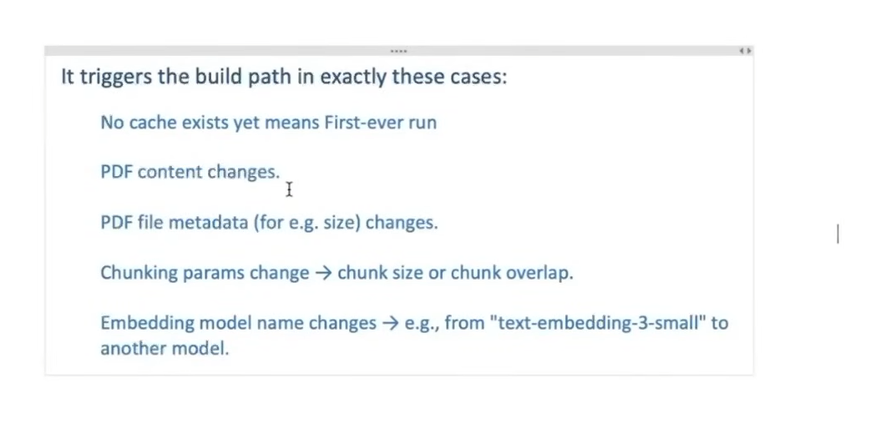

Code:- This is a code for a ReAct agent. All we need to do it to load .env file inside it and if we are only tracing runnables then we don’t even need tracer decorator.
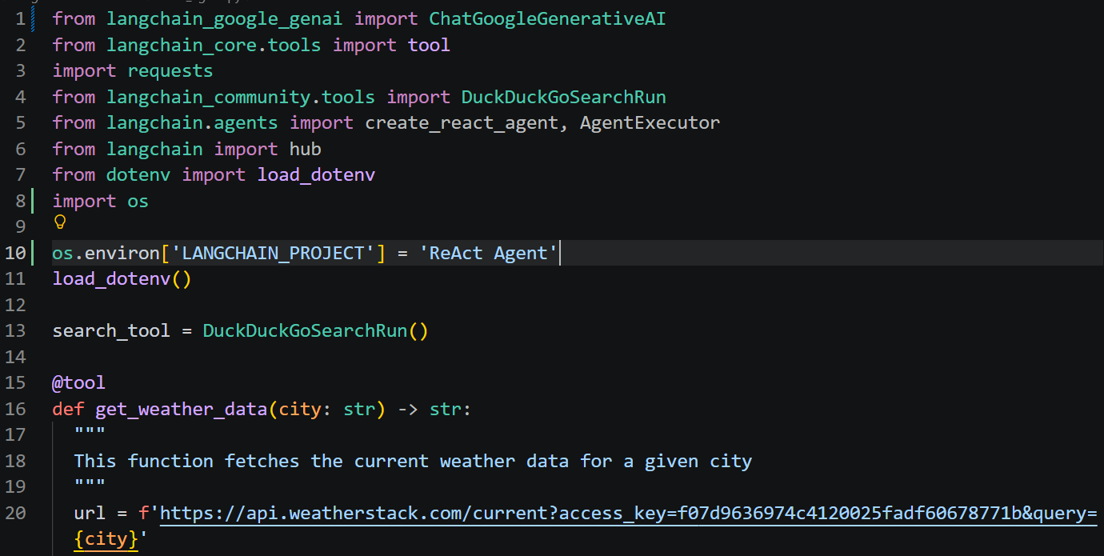
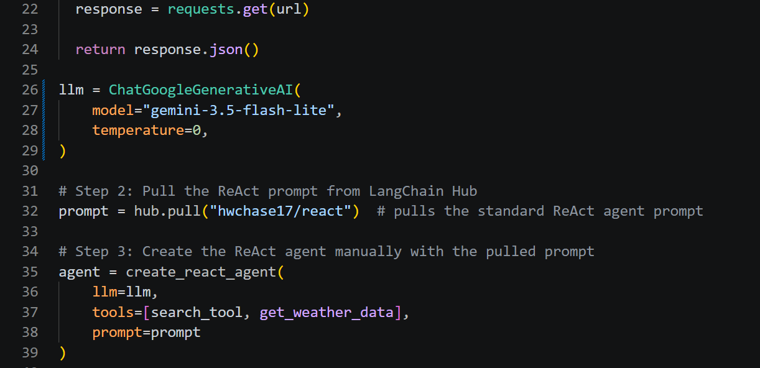
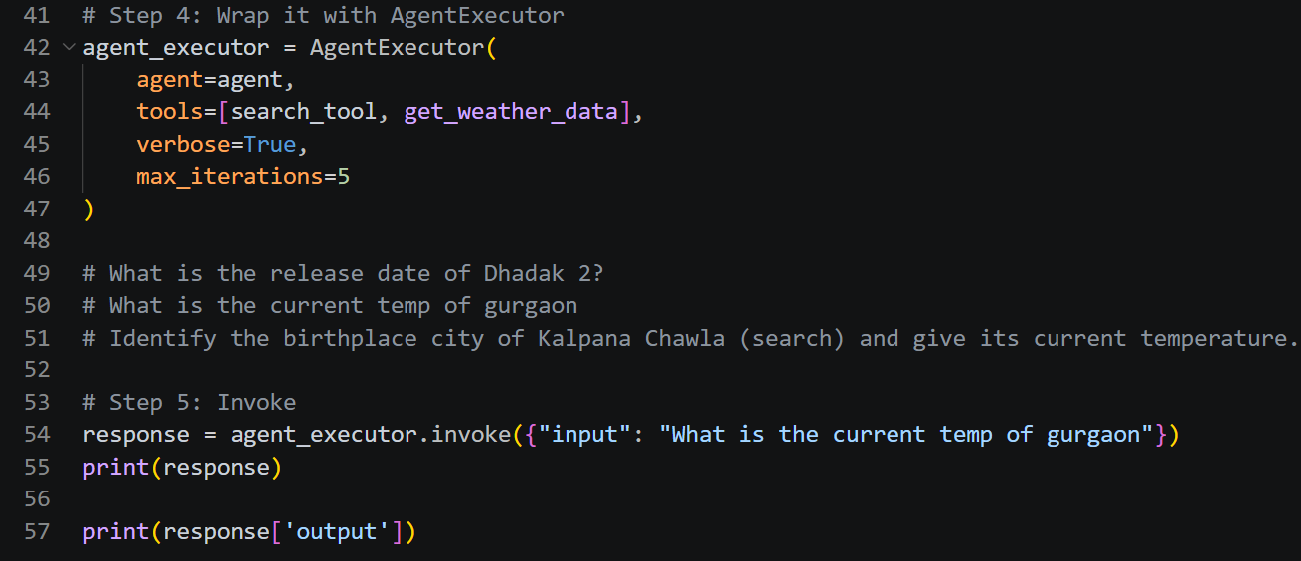
Result:- Because of langsmtih, we get a lot of transparency in this.
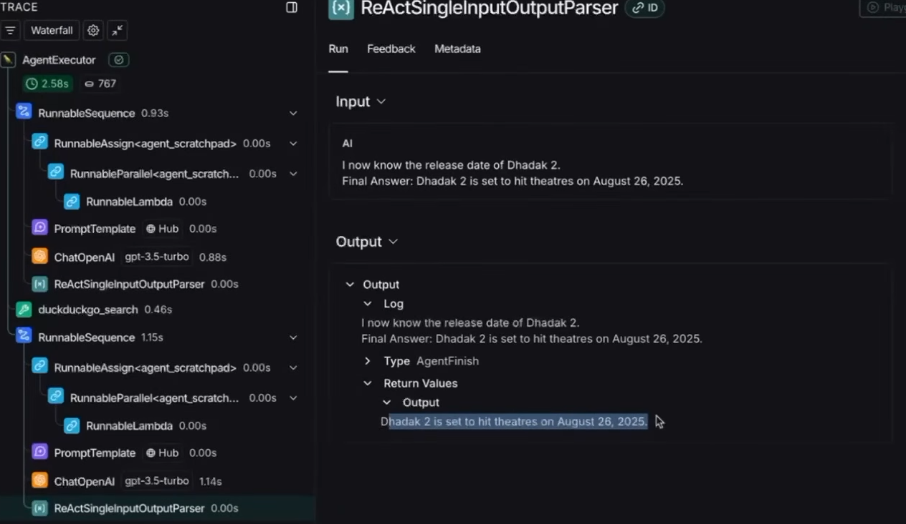

The langsmith is best worked with langraph cause of its complex nature.
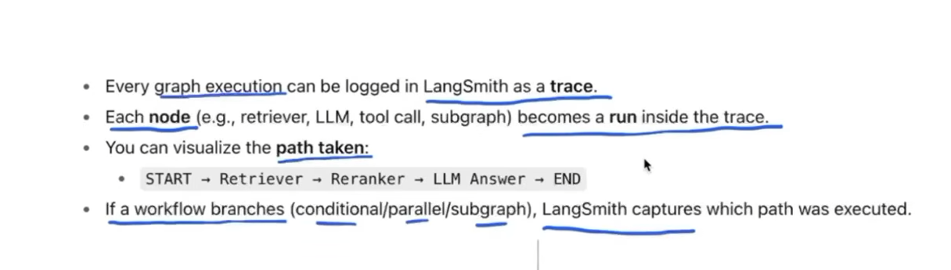
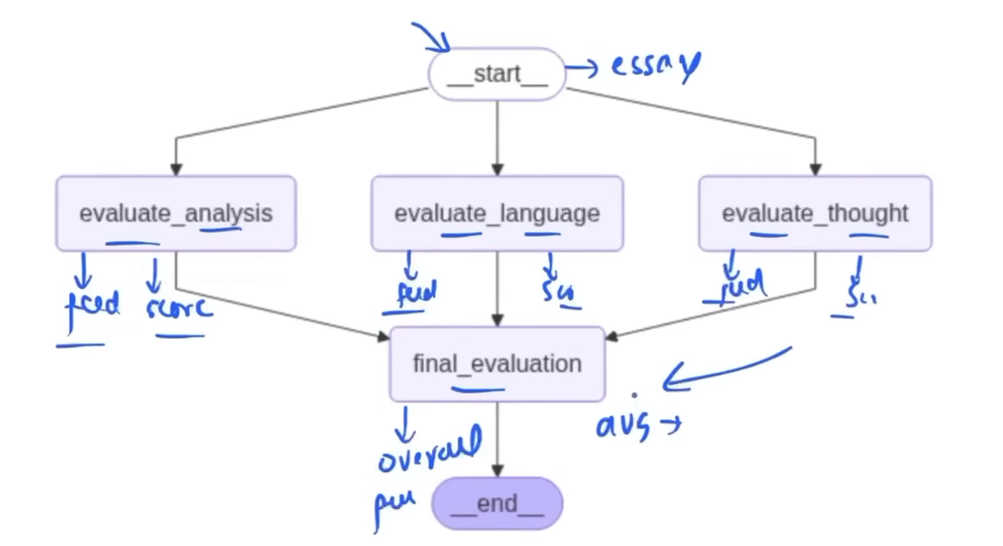

Code:-
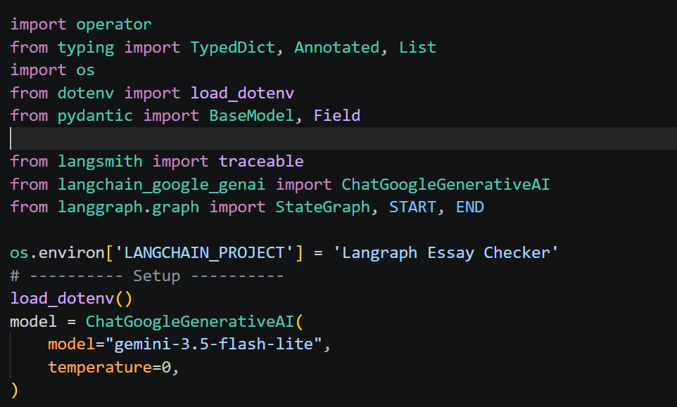
This is just some basic essay, we can ignore in last section.
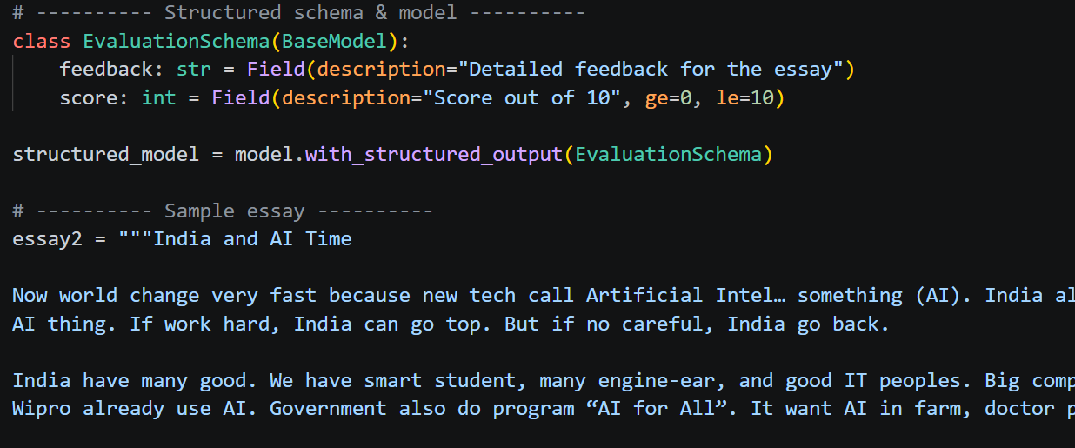
LangSmith automatically traces LangChain/LangGraph nodes and Runnables. We can also manually trace our own Python functions using @traceable.
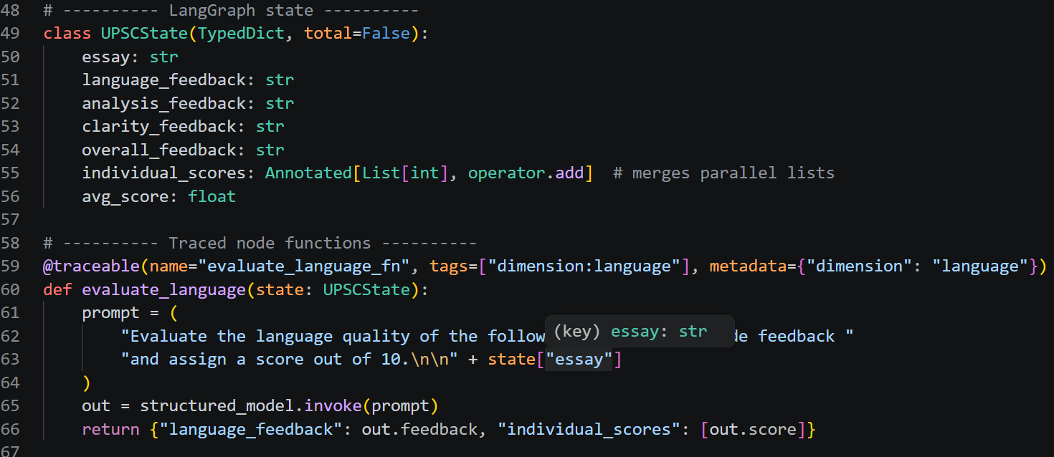
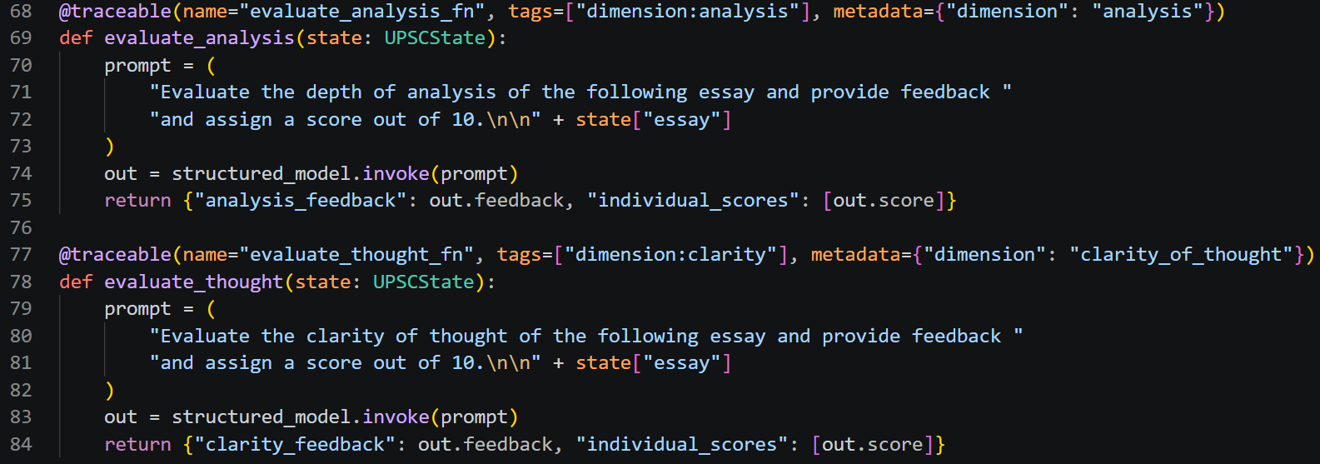
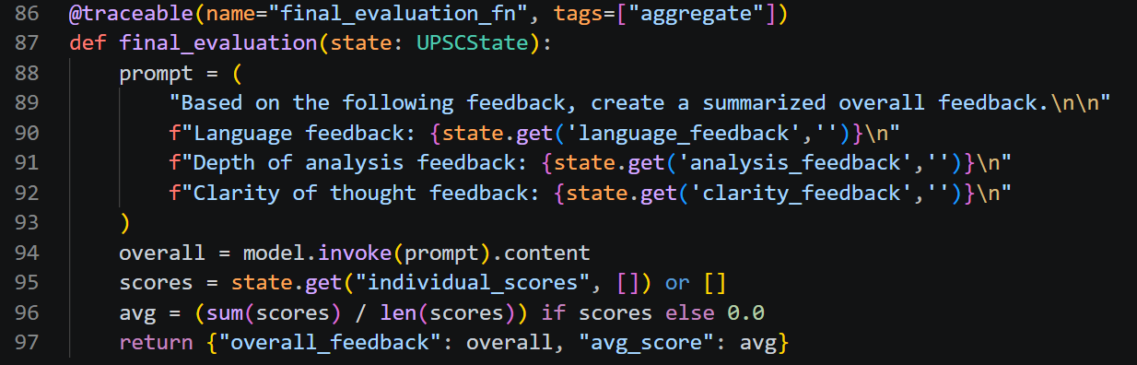
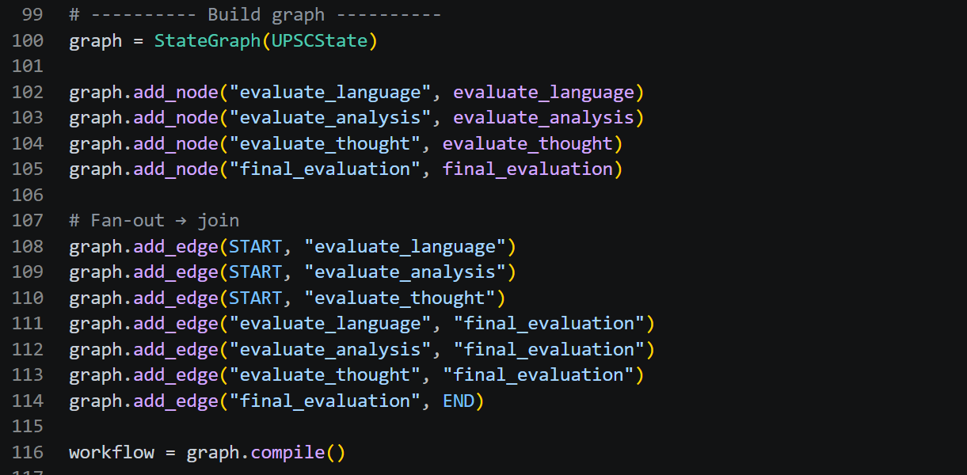

We can change the trace name and also add tags and metadata to provide more information and make the trace easier to identify and filter.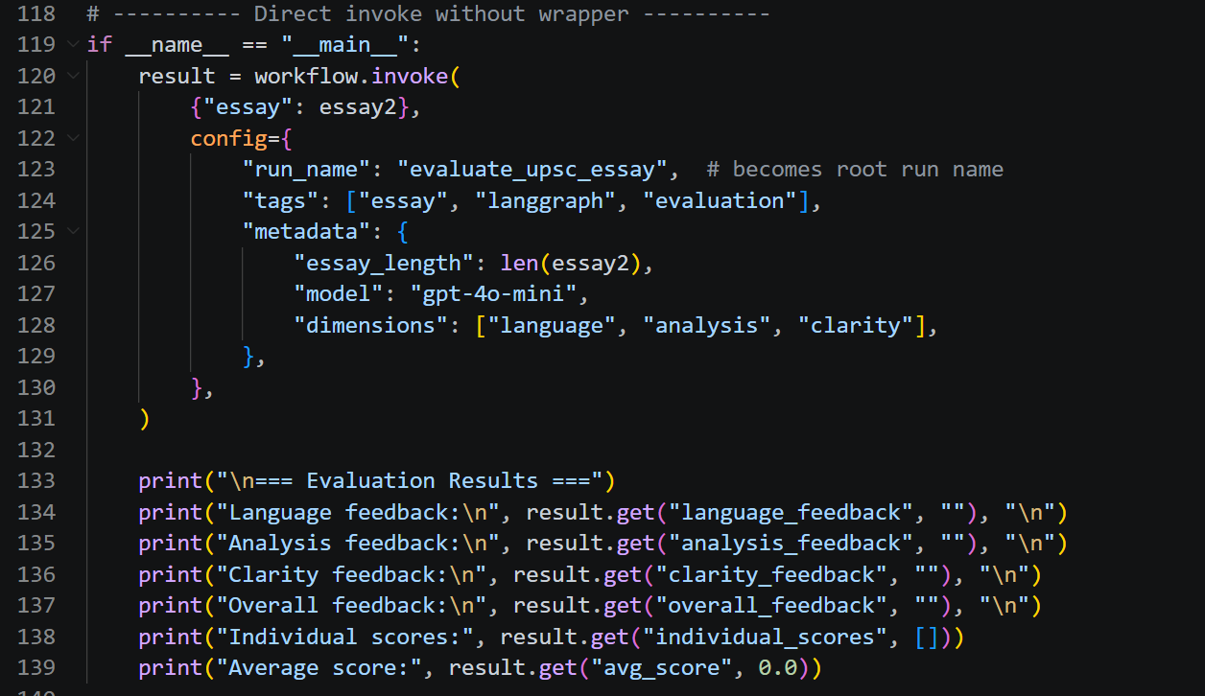

Result:- As we can see, there are 3 nodes, and when we open them, each node can contain multiple functions or operations. LangSmith traces these internal functions as well, including tool calls and other operations.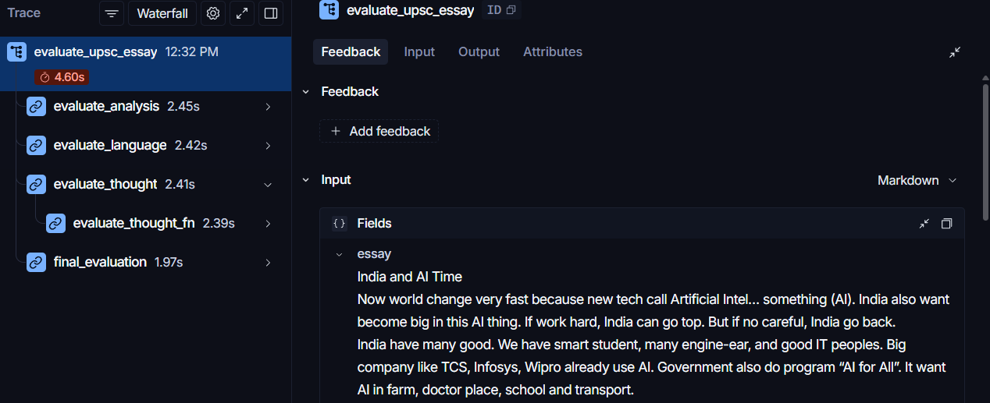

Each function performs its individual task, and we can view the metadata and tags we assigned to each function in LangSmith.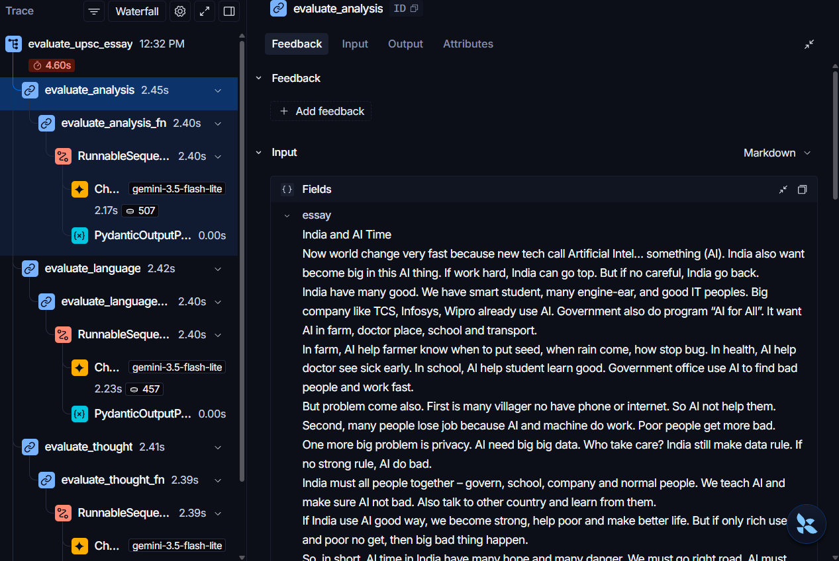

Other uses of langsmith apart from observability :-
Monitoring means continuously observing your LLM application's runs after it has been deployed, to make sure it is working correctly and efficiently.
It helps you track things like:
- Latency → how long each run takes
- Errors → how often runs fail
- Token usage → how many tokens are being consumed
- Cost → API/model costs
- Run volume → how frequently the application is being used
- Quality/evaluation → whether responses are meeting your expected criteria

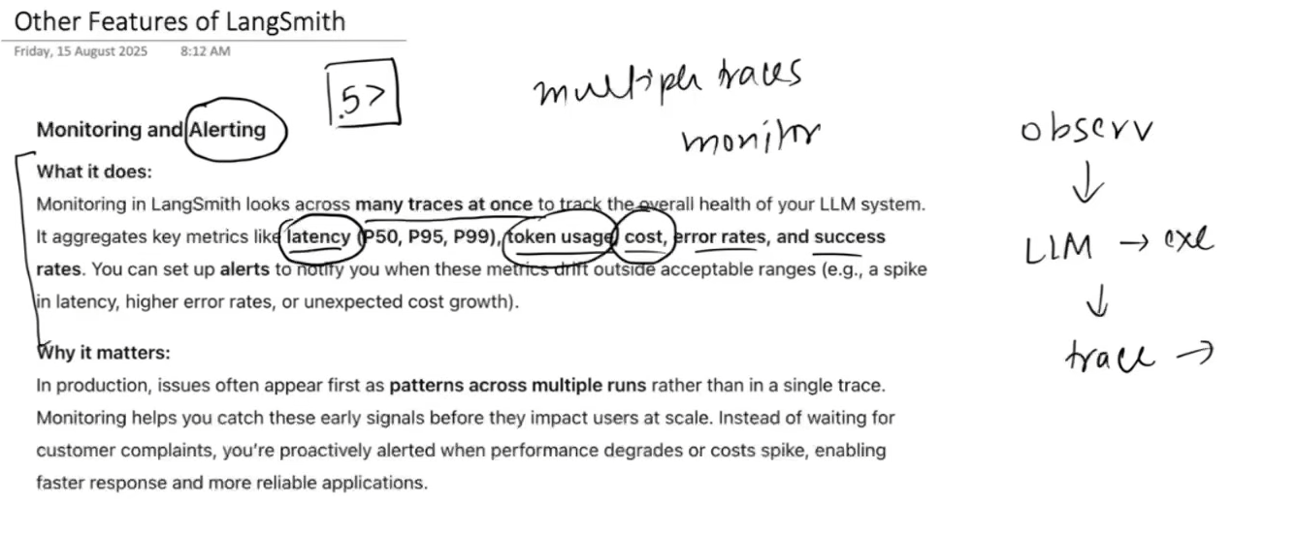

There is a Monitoring section where we can view dashboards, and an Alerts section where we can set up alerts for different projects.
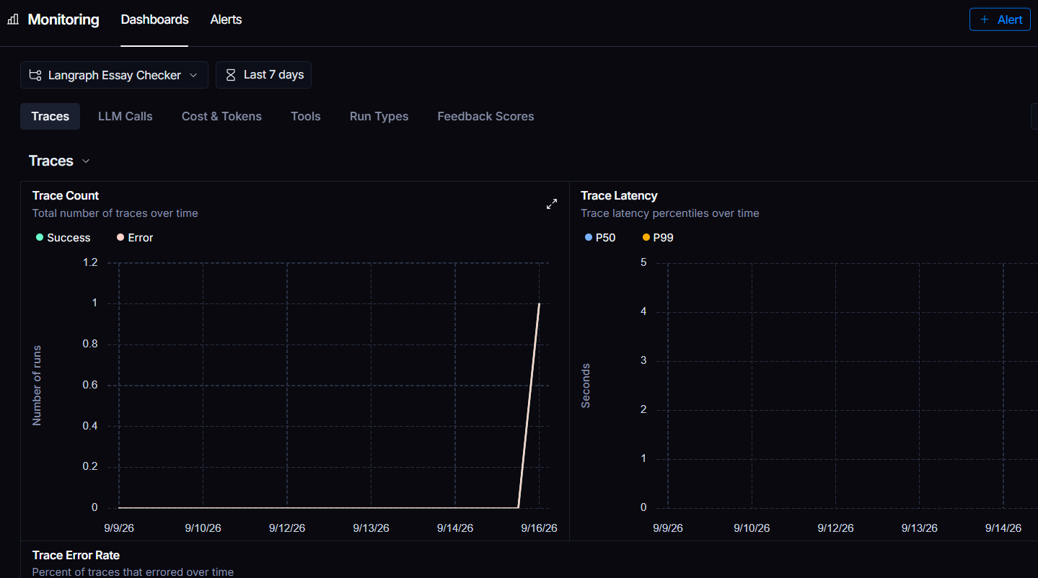
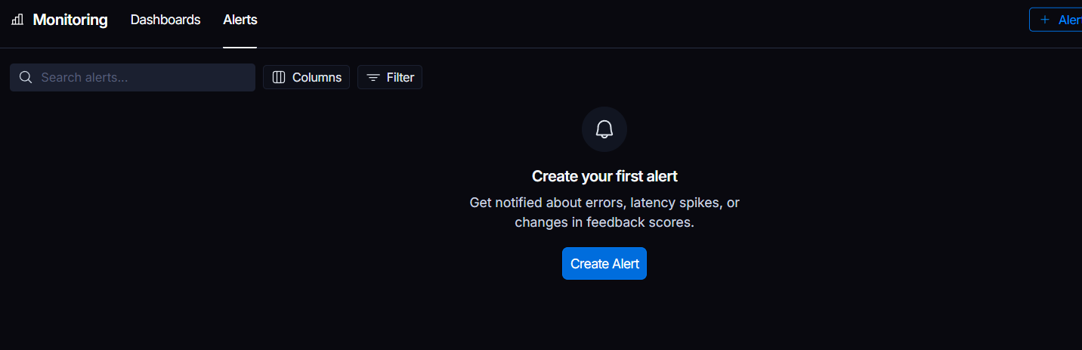

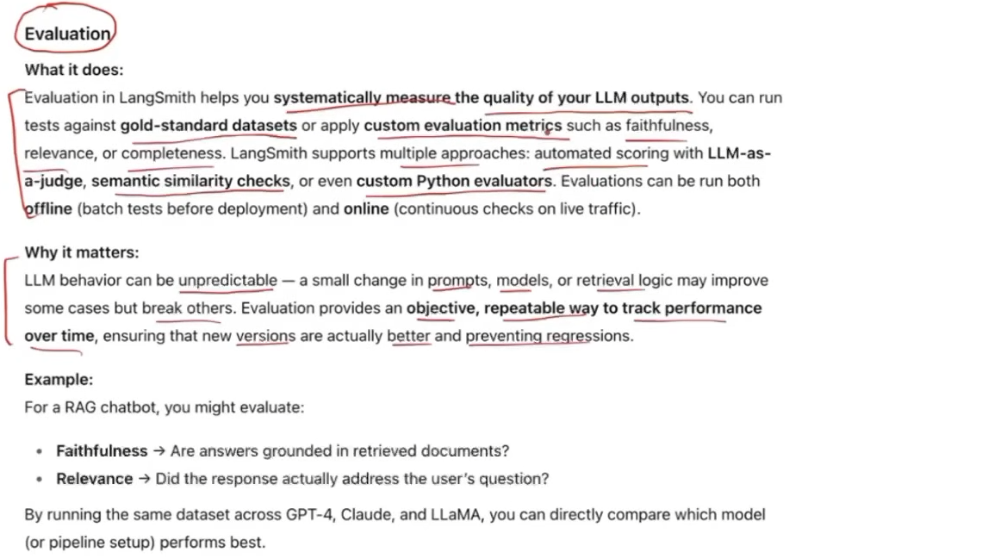
Next to the Tracing section, there is an Evaluators section. Here, we can use custom evaluators that we create ourselves or the pre-built evaluators provided by LangSmith.
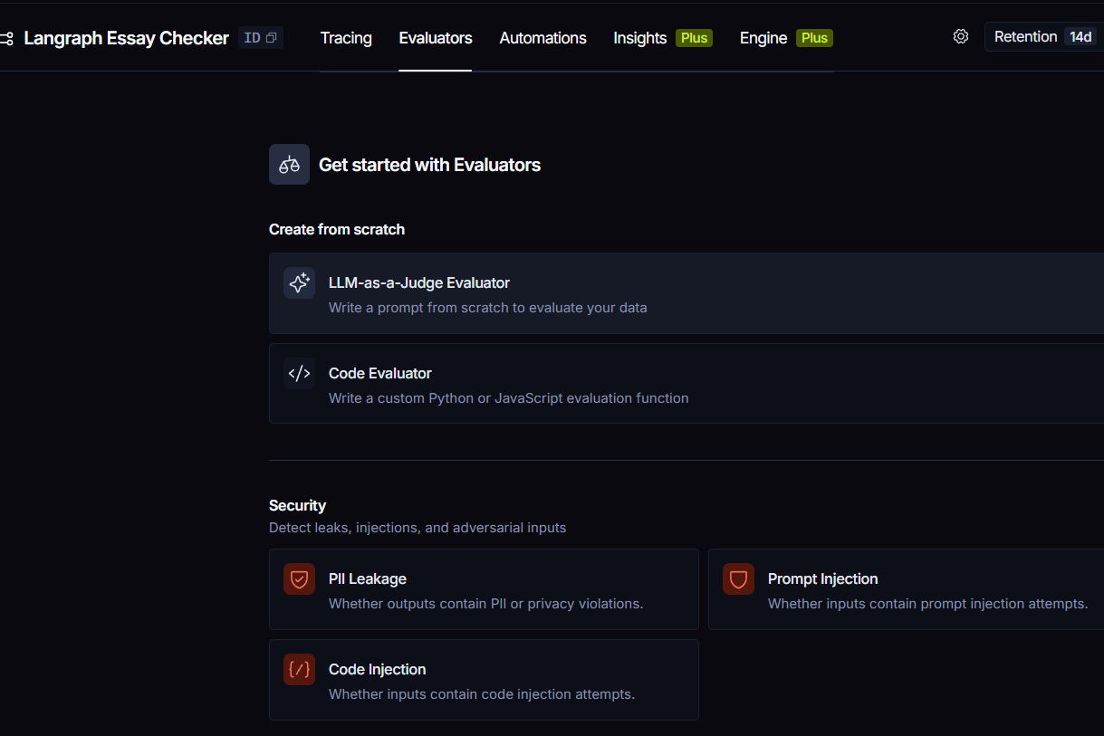
Prompt Experimentation
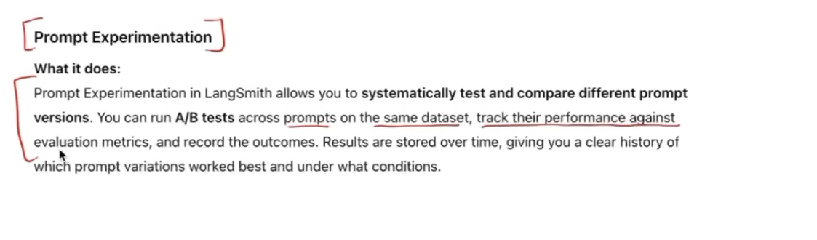

We can also do this in the Playground section, where we can evaluate our LLM application using different metrics such as correctness, relevance, conciseness, and toxicity.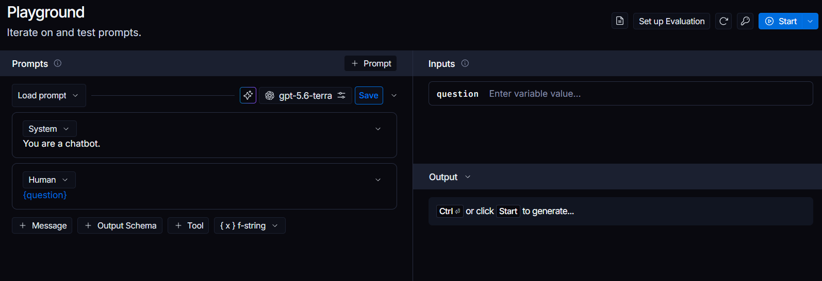
In the Prompt section, we can:
- Create and edit prompts for our LLM applications.
- Version prompts so we can keep track of different changes and iterations.
- Compare different prompt versions to see how changes affect the output.
- Test prompts with different inputs and models.
- Share and reuse prompts through LangSmith Hub.
- Organize prompts so they can be easily used across different projects.
Intuition: Think of it as GitHub for prompts — we can create a prompt, modify it, keep its versions, test it, and share it with others.
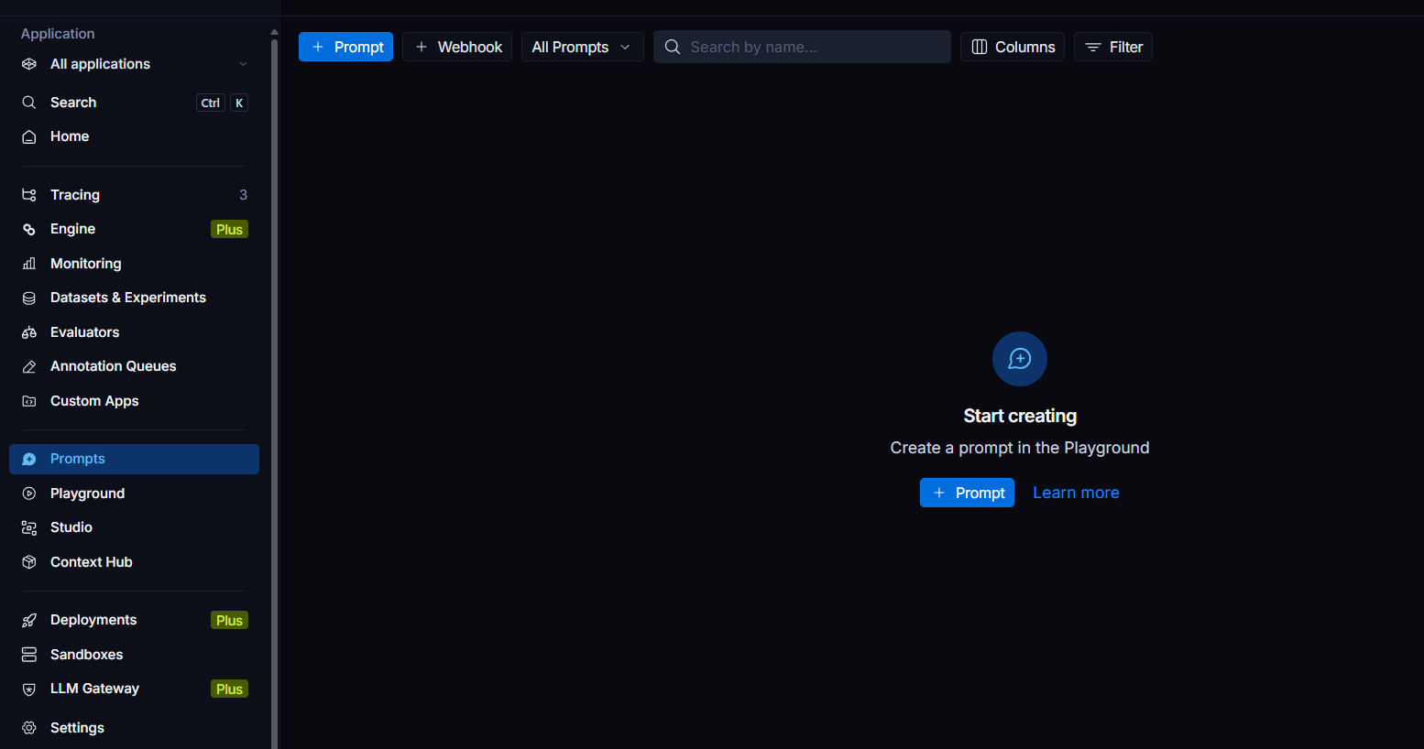

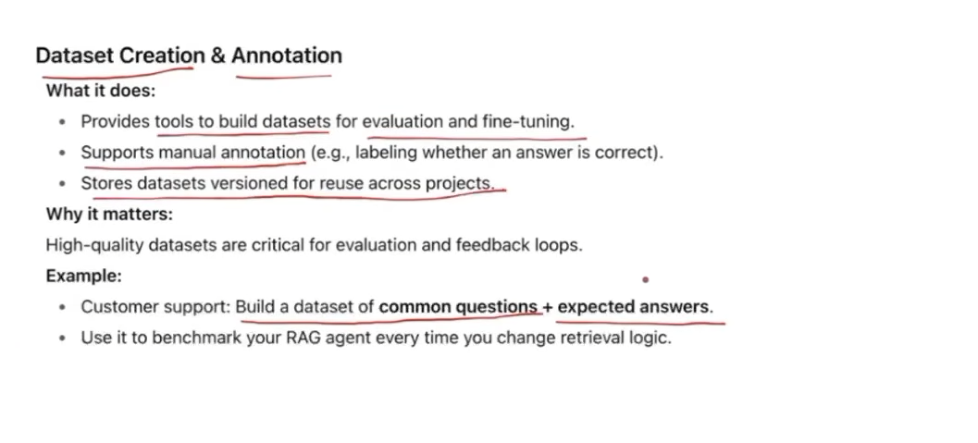

We can create our own datasets from scratch, upload data from our device, or even add data from traces to create dataset examples.
Intuition: Think of datasets as a collection of test cases that we can later use to test and evaluate our LLM application.
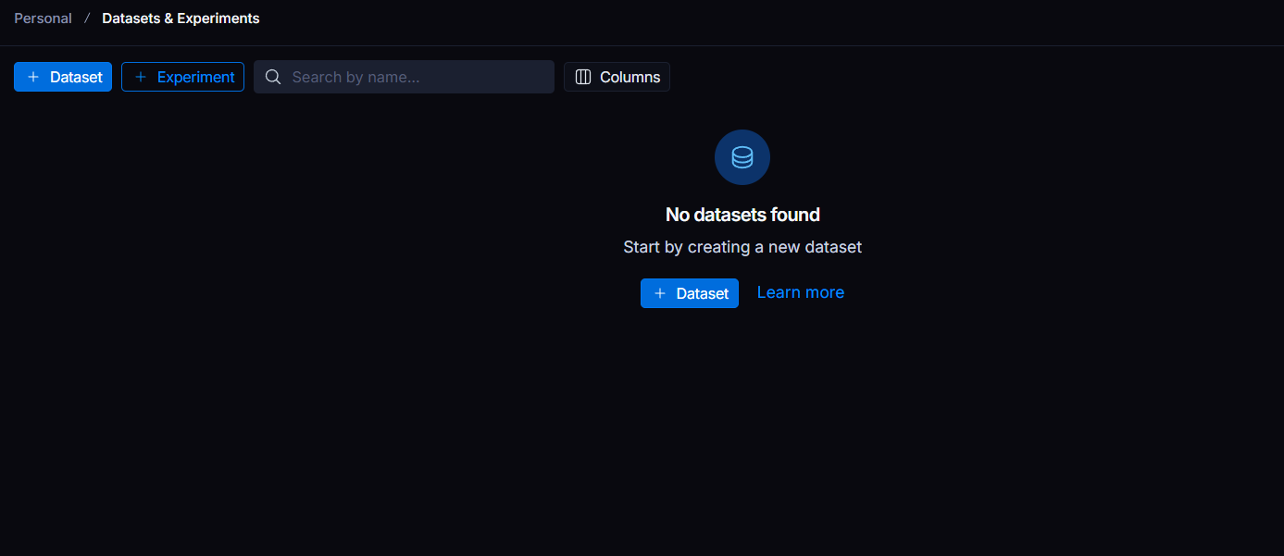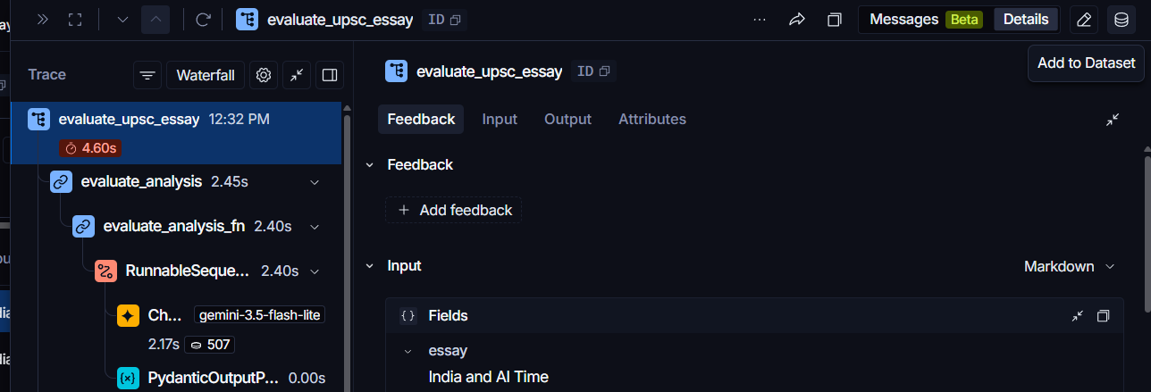

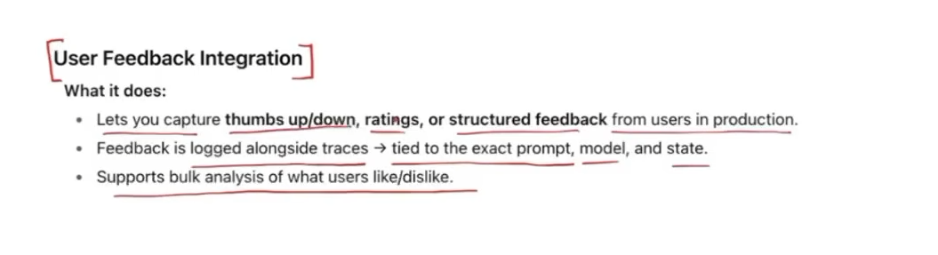
This is where we can add feedback to a trace to evaluate its performance. We can also view this feedback in the dashboard for monitoring and analysis.
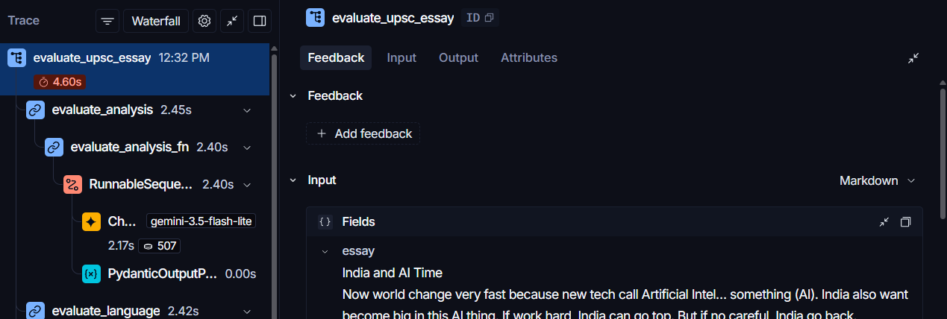

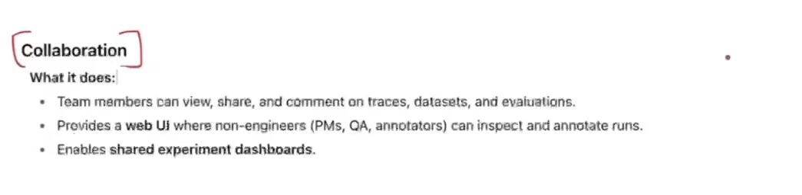
We can share an entire trace with others, allowing them to see exactly what happened during that run, including the steps, inputs, outputs, and other details.